Recent Developments in Synchrotron Mössbauer Reflectometry

L. Deáka, H. Spieringb, L. Bottyána, M. Majora, D.L. Nagya,
E. Szilágyia, F. Tanczikóa

ªKFKI Research Institute for Particle and Nuclear Physics, Budapest, Hungary

^{b}Institute für Anorganische und Analytische Chemie, Johannes Gutenberg Universität,

Mainz, Germany

Synchrotron Mössbauer Reflectometry (SMR), the grazing incidence nuclear resonant scattering of synchrotron radiation, can be applied to perform depth-selective phase analysis and to determine the isotopic and magnetic structure of thin films and multilayers. Principles and methodological aspects of SMR are briefly reviewed. Off-specular SMR provides information from the lateral structure of multilayers. In AF coupled systems the size of magnetic domains can be measured.
1. Introduction
Soon after the discovery of the Mössbauer effect, total external reflection (TER) of nuclear resonant photons was demonstrated []. Nevertheless, only three decades later the need for Mössbauer reflectometry (MR) was formulated [] and its feasibility using strong ⁵⁷Co sources was demonstrated []. A serious limitation of MR with conventional sources is the small (∼10⁻⁵) solid angle involved. Due to its high collimation, synchrotron radiation (SR) is much better suited for reflectometric experiments than radioactive sources. Synchrotron Mössbauer reflectometry (SMR) is the application of grazing incidence nuclear resonant scattering (NRS) of SR to thin film and multilayer structure analysis.
The rigorous derivation of the general formulae for the transmissivity and the reflectivity of γ-radiation in the forward scattering and the grazing incidence case, respectively, were given by Deák et al. []. Like Andreeva et al. [,,,], they started from the Afanas'ev⎯Kagan nucleon current density expression of the dielectric tensor [] and used a covariant anisotropic optical formalism []. Instead of calculating the susceptibility tensor χ from the current densities of the nucleons, however, the problem was reduced to the calculation of the transmittance (forward scattering case) and the reflectivity (grazing incidence case) from the coherent forward scattering amplitude f. In the case of forward scattering, this general approach led to the theory of Blume and Kistner []. Having no intuitive assumptions, Ref [Error: Reference source not found] represents a firm basis of the Blume⎯Kistner theory [Error: Reference source not found] and of the Andreeva approximation [Error: Reference source not found,Error: Reference source not found,Error: Reference source not found,Error: Reference source not found]. The obtained reflectivity formulae in Ref [Error: Reference source not found] are also suitable for fast numerical calculations in order to fit the experimental data [].
Another general description of specular reflection of grazing incidence Mössbauer radiation was given by Hannon et al. [,,,]. Starting from the quantum theory of γ-radiation, they formulated the dynamic theory of Mössbauer optics. Unfortunately, the dynamic theory provides rather slow algorithms for calculating reflectivity spectra; therefore, it is inefficient in spectrum fitting. In the grazing incidence limit, an optical model was derived from the dynamical theory [Error: Reference source not found,Error: Reference source not found], which has been implemented in numerical calculations []. This optical method is equivalent with Ref [Error: Reference source not found], as it was shown later [Error: Reference source not found].
The first successful grazing incidence NRS experiment with SR was performed by Grote et al [] in 1991. Chumakov et al. observed a pure nuclear reflection of SR from an isotopically periodic ⁵⁷Fe/Sc/⁵⁶Fe/Sc multilayer []. Alp et al. reported on the observation of nuclear resonant specular reflection with ¹¹⁹Sn resonance []. An important step towards the realization of SMR was the observation [] of the total reflection peak [Error: Reference source not found,], i.e. the high number of delayed photons appearing close to the critical angle of the electronic TER. The first SMR experiment aiming to study the magnetic structure of an anti-ferromagnetic (AF) ⁵⁷Fe/Cr multilayer was done by Toellner et al. []. The last years saw an increasing number of SMR experiments that is a standard method for studying multilayers and thin films. In the next section we explain the basic principles of SMR.
2. Basic concepts of specular SMR
In NRS of SR the low-lying levels of an ensemble of identical nuclei are coherently excited by the synchrotron radiation pulse. Since the levels are, as a rule, split by hyperfine interactions, the spatial and temporal coherence of the scattering results in characteristic patterns both of the angular distribution and the time evolution of the scattered radiation, which bear simultaneous and correlated information about topology and internal fields in the sample under study. SR is scattered both by nuclei and by electrons and these two processes interfere with each other, as well. Conventional Mössbauer spectroscopy and NRS of SR are, although delivering similar information on hyperfine interaction and lattice dynamics, complementary rather than equivalent to each other. The principal difference is that when the energy spectrum is scanned by the Doppler-shifted radiation of a γ-source, the recorded signal presents the incoherent sum of the spectral components of the transmitted radiation. In case of time domain NRS of SR, however, the response is formed by the coherent sum of the spectral components of the scattered radiation.
The specular SMR measurement is performed in θ–2θ geometry in either time integral (TISMR) or time differential regime (TDSMR). TISMR means recording the total number of delayed photons from t₁ to t₂ as a function of θ where t₁ is a few nanoseconds determined by the bunch quality of the radiation source and by the dead time of the detector and the electronics while t₂ is a value somewhat below the bunch repetition time of the storage ring. As a rule, a θ–2θ scan of the prompt photons (conventionally called x-ray reflectometry) is recorded along with a delayed time integral SMR scan. TDSMR is a time response measurement in a fixed θ–2θ geometry performed at different values of θ. Like in the forward scattering case, hyperfine interaction results in quantum beats of the time response. The first step of an SMR measurement is usually to take a TISMR scan to select θ values of high enough delayed count rate where TDSMR measurements can be performed. These can be found in the region of the total reflection peak [Error: Reference source not found,Error: Reference source not found] and, in case of electronic or nuclear periodicity, in the region of electronic or nuclear Bragg reflections. A full SMR measurement consists of a prompt, a delayed time integral specular reflectivity scan, and a set of time response reflectivity measurements of the delayed photons. To extract the depth profile of hyperfine interactions with confidence, all these data should be evaluated simultaneously. If a full SMR measurement is not feasible for intensity reasons, a TISMR scan may still contain valuable information for the structure of the thin film.
Giving qualitative picture from the method we show a simple example on Fig. 1., the simulation of a hypothetical two-dimensional energy-domain reflectivity spectrum of a: float glass/[⁵⁷Fe(3.0nm)/⁵⁶Fe(1.5nm)]₁₀ isotope periodical multilayer.
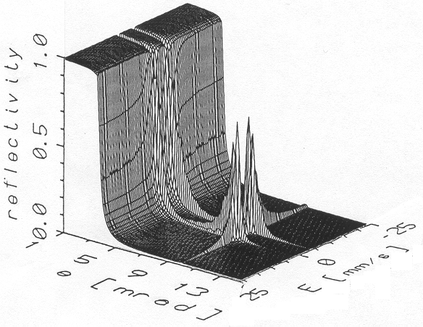
Figure 1
Energy-domain reflectivity of ⁵⁷Fe/⁵⁶Fe multilayer
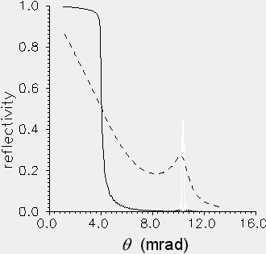
Figure 2
Reflectivity curves at resonance (E= 3.072 mm/s, dashed line) and at E =25 mm/s (solid line)
Figure 3
Mössbauer spectrum at the Bragg position (θ = 10.123 mrad)
MR is a unification of reflectometry and Mössbauer spectroscopy. Indeed, taking the cross-sections at fix energies E on Fig. 1, we get reflectometry spectra, as shown on Fig. 2. For the given energies E having the index of reflection n from the expression of Lax [] and using the optical picture [Error: Reference source not found,Error: Reference source not found], reflectometry spectra can be calculated as generalized Fresnel- formulae [Error: Reference source not found,Error: Reference source not found]. Because of the isotropic periodicity we have a Bragg-peak at θ = 10.123 mrad on Figs 1 and 2 for energies near the resonance. Far from the resonances, however, only the electronic scattering has considerable probability, so the spectrum is the x-ray reflectivity curve. From point of view of electronic scattering, the isotopic structure does not give any contrast, and the Bragg-peak disappears. On the other part, taking the cross-sections at fix grazing angles θ we get the energy dependent Mössbauer spectra (Fig 3). In the model, the hyperfine field was parallel to the surface of the multilayer and transversal electric (TE), viz. σ-polarized, incident beam was assumed. In this special case there are only two Mössbauer lines at E = ±3.072 mm/s. The broadening and asymmetry of the individual lines are caused bye the multiple scattering and the strong dispersion near the nuclear resonance; furthermore the asymmetry between the lines are caused by the electronic scattering.
Using SR as source, the simultaneous broadband coherent excitation results time-domain SMR spectra, those are the Fourier-transformed of the complex energy-domain reflectivity curves, as shown on Fig. 4. The TDSMR spectra, we measure (Fig. 5), are the cross-sections at fix grazing angle θ of the two-dimensional surface on Fig. 4. TISMR means integration of the TDSMR spectra from t₁ to t₂ as a function of θ, where t₁ and t₂ define fix time interval (Fig. 6), as it was explained in the previous paragraphs.
On the TISMR spectrum (Fig 6) we also see the Bragg peak (θ = 9 mrad) [] and an additional peak at the critical angle, θ = 3.67 mrad, this latter being the interference effect of the electronic a nuclear scattering of photons [Error: Reference source not found,Error: Reference source not found]. There is no Bragg peak on the x-ray reflectivity curve [Fig 6], as it was explained earlier.
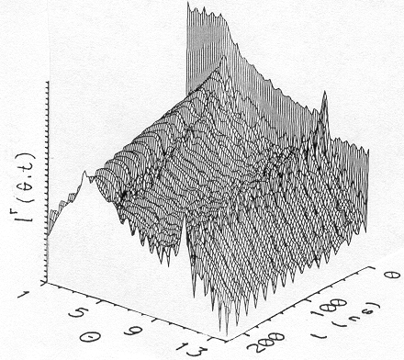 Figure 4
Time-domain reflectivity spectrum of ⁵⁷Fe/⁵⁶Fe multilayer
3. Off-specular SMR
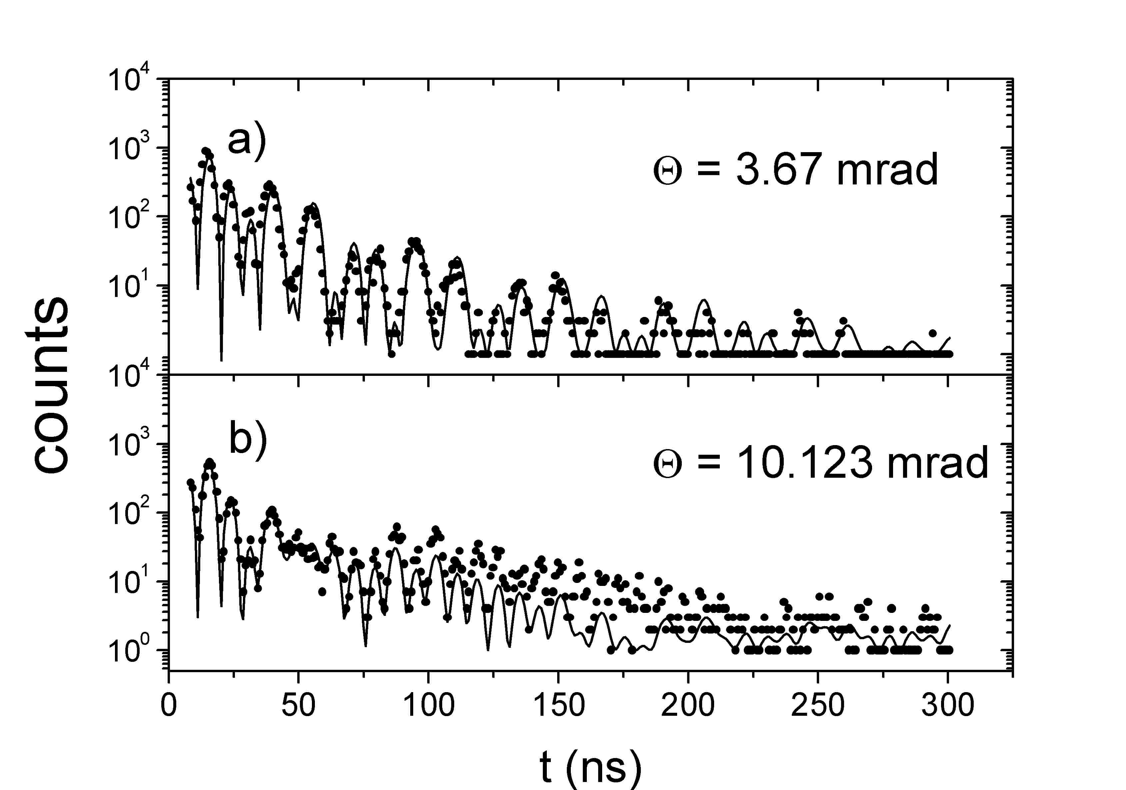
Figure 5
Experimental and theoretical TDSMR spectra of ⁵⁷Fe/⁵⁶Fe multilayer at θ = 3.67 mrad (near the critical angle) (a) and at θ = 10.123 mrad (Bragg position) (b).
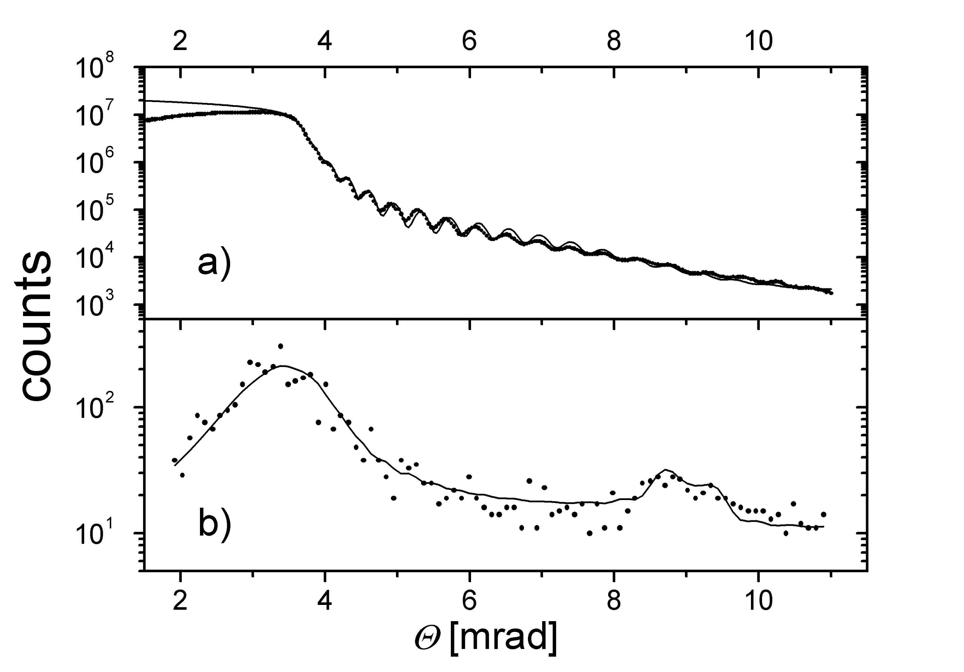
Figure 6
Non-resonant x-ray reflectivity (a) and TISMR (b) spectra of ⁵⁷Fe/⁵⁶Fe
The specularly reflected radiation from layered systems does not depend on the lateral structure; it depends only on the lateral averages of material parameters [Error: Reference source not found,]. For studying lateral inhomogenities, such as magnetic domains etc., one can apply off-specular reflectometry. One possibility for off-specular reflectometry is the geometry called 'ω-scan', where we set the value of 2 Θ (we fix the height of the detector) and vary the sample orientation ω (leaving the constraint of specular reflection ω = Θ)
Starting from the general theory of Lax [Error: Reference source not found] the off-specular intensity I_{off} can be expressed by the Fourier transformed of the depth profile of the coherent field inside the layers $T\left(k_{}^{'}\right)$ ($k_{}^{'}$ is the perpendicular component of the momentum of the scattered wave) and by the lateral Fourier transformed of the autocorrelation function of susceptibilities C(K_{II}) (K_{II} being the later component of the momentum transfer vector)
$I_{\text{off}}∝\text{Tr}\left[T^{+}\left(k_{}^{'}\right) C\left(K_{\text{II}}\right)T\left(k_{}^{'}\right)ρ\right]$,
where ρ is the polarization density matrix of the incident radiation []. As 0th approximation we may assume that the autocorrelation function is exponential and so I_{off} ∝ C(K_{II}) is Lorentian [Error: Reference source not found] It follows that the correlation length is inversely proportional to the widths of the Lorentian.
Fig. 7 shows the off-specular x-ray reflectometry (‘prompt’) and off-specular SMR (‘delayed’) measurements on MgO(001)[⁵⁷Fe(26Å)/Cr(13Å)]₂₀ AF multilayer at the AF-Bragg position. The x-ray ω-scan resulted in a narrow line, indicating that there were no chemical inhomogenities in the lateral direction, additionally the the wide Lorentian on the delayed ω-scan shows the lateral inhomogenity in the hyperfine magnetic field as a result of the magnetic domains. From the Lorentian fit (solid line on Fig. 7) we get 0.8 μm average domain size.
Because of the underlying common optical approach the same theory can be applied for SMR, x-ray reflectometry, spin polarized neutron reflectometry [Error: Reference source not found] and x-ray resonance exchange scattering [,]. The computer program EFFI (Environment For FItting) based on this calculus is freely available [Error: Reference source not found,].
Figure 7
Prompt and delayed off-specular scans on MgO(001)[⁵⁷Fe(26Å)/Cr(13Å)]₂₀ AF multilayer at the AF-Bragg position. The solid line shows the Lorentian fit.

4. Conclusion
A short overview of specular and off-specular SMR was given. Off-specular SMR is sensitive to the lateral structure of the hyperfine fields, so it can be used for studying magnetic domains in multilayers. Using the method we found 0.8 μm average domain size in a MgO(001)[⁵⁷Fe(26Å)/Cr(13Å)]₂₀ AF multilayer. The off-specular data evaluation will be soon available in EFFI.

Acknowledgements
This work was partly supported by the Hungarian Scientific Research Fund (OTKA) under Contract Nos. T029409 and by the Hungarian Academy of Sciences (Contact No. AKP 97-104 2,2/17). The financial support by the by the Flemish-Hungarian bilateral project BIL 98-20 is gratefully acknowledged. The access to SR was generously made possible by ESRF Grenoble and HASYLAB Hamburg.

[?] S. Bernstein and E.C. Campbell, Phys. Rev. 132 (1963) 1625.
[?] D.L. Nagy and V.V. Pasyuk, Hyp. Int. 71 (1992) 1349.
[?] S.M. Irkaev, M.A. Andreeva, V.G. Semenov, G.N. Belozerskii and O.V. Grishin, Nucl. Instrum. Methods B 74 (1993) 545.
[?]L. Deák, L. Bottyán, D.L. Nagy and H. Spiering, Phys. Rev. B. 53 (1996) 6158.
[?] S. M. Irkaev, M. A. Andreeva, V. G. Semenov, G. N. Beloserskii, and O. V. Grishin, Nucl. Instrum. Methods B 74 (1993) 554.
[?] M. A. Andreeva, S. M. Irkaev, and V. G. Semenov, Sov. Phys.⎯JETP 78 (1994) 965.
[?] M. A. Andreeva and R. N. Kuz'min, Messbauerovskaya Gamma-Optika (Moscow University, 1982).
[?] M. A. Andreeva and K. Rosete, Poverkhnost' 9 (1986) 145; Vestnik Mosk. Univ., Ser. 3. Fiz. Astron. 27 (1986) 57.
[?] A. M. Afanas'ev and Yu. Kagan, Sov. Phys. ⎯JETP 21 (1965) 215.
[?] G. M. Borzdov, L. M. Barskovskii, and V. I. Lavrukovich, Zh. Prikl. Spektrosk. 25 (1976) 526.
[?] M. Blume and O. C. Kistner, Phys. Rev. 171 (1968) 417.
[?] H. Spiering, L. Deák, and L. Bottyán, Hyp. Int. 125 (2000) 197.
[?] J. P. Hannon and G. T. Trammell, Phys. Rev. 169 (1968) 315.
[?] J. P. Hannon and G. T. Trammell, Phys. Rev. 186 (1969) 306.
[?] J. P. Hannon, N. V. Hung, G. T. Trammell, E. Gerdau, M. Mueller, R. Rüffer, and H. Winkler, Phys. Rev. B 32 (1984) 5068.
[?] J. P. Hannon, G. T. Trammell, M. Mueller, E. Gerdau, R. Rüffer, and H. Winkler, Phys. Rev. B 32 (1985) 6363.
[?] R. Röhlsberger, Ph.D. thesis, University Hamburg, 1994.
[?] M. Grote, R. Röhlsberger, M. Dimer, E. Gerdau, R. Hellmich, R. Hollatz, J. Jäschke, E. Lüken, J. Metge, R. Rüffer, H.D. Rüter, W. Sturhahn, E. Witthoff, M. Harsdorff, W. Pfützner, M. Chambers and J.-P. Hannon, Europhys. Lett. 14 (1991) 707.
[?] A.I. Chumakov, G.V. Smirnov, A.Q.R. Baron, J. Arthur, D.E. Brown, S.L. Ruby, G.S. Brown and N.N. Salashchenko, Phys. Rev. Lett. 71 (1993) 2489.
[?] E.E. Alp, T.M. Mooney, T. Toellner, W. Sturhahn, E. Witthoff, R. Röhlsberger, E. Gerdau, H. Homma and M. Kentjana, Phys. Rev. Lett. 70 (1993) 3351.
[?] A.Q.R. Baron, J. Arthur, S.L. Ruby, A.I. Chumakov, G.V. Smirnov and G.S. Brown, Phys. Rev. B 50 (1994) 10354.
[?] L. Deák, L. Bottyán and D.L. Nagy, Hyp. Int. 92 (1994) 1083.
[?] T.L. Toellner, W. Sturhahn, R. Röhlsberger, E.E. Alp, C.H. Sowers and E.E. Fullerton, Phys. Rev. Lett. 74 (1995) 3475.
[?] M. Lax, Rev. Mod. Phys. 23 (1951) 287.
[?] The Bragg position is different, because the model system differs by this measurement and simulation. The sample was: float glass/⁵⁷Fe(4.6 nm)/[⁵⁶Fe(2.9 nm)/⁵⁷Fe(2.3 nm)]15/Al(5.7 nm)
[?] L. Deák, L. Bottyán, D.L. Nagy, and H. Spiering, Physica B 297 (2001) 113.
[?] L. Deák, to be published
[?] J.P. Hannon, G.T. Trammell, M. Blume, and Doon Gibs, Phys. Rev. Lett. 61 (1988) 1245.
[?] L. Deák et al., to be published (not yet implemented into our data evaluation program, EFFI)
[?] The computer program EFFI is available from ftp://iacgu7.chemie.uni-mainz.de/pub/effi

