Stroboscopic detection of Synchrotron Mössbauer Reflectometry Spectra
L. Deák
KFKI Research Institute for Particle and Nuclear Physics, P.O.B. 49, H–1525 Budapest, Hungary
Synchrotron Mössbauer Reflectometry (SMR), the grazing incidence nuclear resonant scattering of synchrotron radiation, can be applied to perform depth-selective phase analysis and to determine the isotopic and magnetic structure of thin films and multilayers. Principles and methodological aspects of SMR are briefly reviewed. An alternative experimental method for detecting nuclear resonant scattering of synchrotron radiation is the heterodyne method, that is based on the interference of radiation scattered by two absorbers, those are moving relative each others. Model calculations on ⁵⁶Fe/⁵⁷Fe isotopic periodical and ⁵⁷Fe/Cr multilayers demonstrate that heterodyne and/or stroboscopic detection of SMR spectra is also possible. The sensitivity of the method for the orientation of the hyperfine magnetic fields, for the thickness of the reference layer and for the period time of the synchrotron bunches are also discussed.
1. Introduction
A great majority of Mössbauer experiments is performed on polycrystalline samples without applying an external magnetic field. In such cases, the polarization of the γ-rays plays no role, the Mössbauer spectrum can be described in terms of resonant and non-resonant absorption and the resonant absorption cross-section can be calculated from the parameters of the hyperfine interaction. This naive approach fails if the Mössbauer experiment is performed on a single crystal or a textured sample and/or in an external magnetic field. The resonant cross-section in these latter cases depends on the polarization and the full polarization-dependent scattering problem has to be treated. The numerical difficulties of the scattering approach stem from the great number of randomly distributed scattering centers. These difficulties can be circumvented if, akin to classical optics, a continuum model rather than a microscopic scattering theory can be used. It is by no means trivial, however, that such an optical approach for γ-rays in condensed matter is feasible since the mean distance of scattering centers is usually greater than the wavelength of the scattered radiation. It has been shown, however, by Lax [] that, at least for scalar waves, a close to unity index of refraction n can be defined and simply related to the coherent forward scattering length f, provided that the momentum of the scattering centers is small compared to that of the incident wave. Since Lax's paper [Error: Reference source not found], the refraction index approach has been used extensively in neutron and x-ray optics. The heuristic generalization of this approach to polarized waves and for an anisotropic medium, although claimed to be trivial by Lax is by no means straightforward and needs further elucidation.
In the forward scattering geometry, the polarization dependence of the Mössbauer absorption of γ-radiation was theoretically studied by Blume and Kistner []. Instead of using a $3×3$ index of refraction matrix, they accepted Lax's intuitive suggestion [Error: Reference source not found], and used a complex $2×2$ index of refraction matrix n, corresponding to the two possible independent states of polarization of the radiation. n was then related to the coherent forward scattering amplitude [Error: Reference source not found].
Soon after the discovery of the Mössbauer effect, total external reflection (TER) of nuclear resonant photons was demonstrated []. Nevertheless, only three decades later the need for Mössbauer reflectometry (MR) was formulated [] and its feasibility using strong ⁵⁷Co sources was demonstrated []. Beside the conventional forward scattering case, grazing incidence Mössbauer spectroscopy (GIMS) has gained considerable recent attention in studying stratified media: surfaces, interfaces and multilayers [Error: Reference source not found,Error: Reference source not found,,,]. This method utilizes geometry such that the γ-rays are incident on the flat surface of the sample at glancing angles θ of a few mrad close to the critical angle of the electronic TER. The detected scattered particles are specularly reflected γ-photons, conversion electrons, conversion x-rays and incoherently scattered γ-photons. A serious limitation of MR with conventional sources is the small (∼10⁻⁵) solid angle involved. Due to its high collimation, synchrotron radiation (SR) is much better suited for reflectometric experiments than radioactive sources. Synchrotron Mössbauer reflectometry (SMR) is the application of grazing incidence nuclear resonant scattering (NRS) of SR to thin film and multilayer structure analysis.
A general treatment of GIMS was published by Andreeva et al. in several papers [Error: Reference source not found,Error: Reference source not found,,]. Starting from the nucleon current density expression of the susceptibility tensor χ given by Afanas'ev and Kagan [] and using a covariant formalism of anisotropic optics [] first introduced by Fedorov [] these authors take into account that both the elements of the susceptibility tensor χ and the glancing angle θ are small in GIMS and calculate the γ-reflectivity. The method of calculation, however, especially for the higher multipolarity nuclear transitions, is rather cumbersome, since the nucleon current densities are directly calculated resulting in quite complex tensor expressions.
The rigorous derivation of the general formulae for the transmissivity and the reflectivity of γ-radiation in the forward scattering and the grazing incidence case, respectively, were given by Deák et al. []. Like Andreeva et al. [Error: Reference source not found,Error: Reference source not found,Error: Reference source not found,Error: Reference source not found], they started from the Afanas'ev⎯Kagan nucleon current density expression of the dielectric tensor [Error: Reference source not found] and used a covariant anisotropic optical formalism [Error: Reference source not found,Error: Reference source not found]. Instead of calculating the susceptibility tensor χ from the current densities of the nucleons, however, the problem was reduced to the calculation of the transmittance (forward scattering case) and the reflectivity (grazing incidence case) from the coherent forward scattering amplitude f. In the case of forward scattering, this general approach led to the theory of Blume and Kistner [Error: Reference source not found]. Having no intuitive assumptions, Ref [Error: Reference source not found] represents a firm basis of the Blume⎯Kistner theory [Error: Reference source not found] and of the Andreeva approximation [Error: Reference source not found,Error: Reference source not found,Error: Reference source not found,Error: Reference source not found]. The obtained reflectivity formulae in Ref [Error: Reference source not found] are also suitable for fast numerical calculations in order to fit the experimental data [].
Another general description of specular reflection of grazing incidence Mössbauer radiation was given by Hannon et al. [,,,]. Starting from the quantum theory of γ-radiation, they formulated the dynamic theory of Mössbauer optics. Unfortunately, the dynamic theory provides rather slow algorithms for calculating reflectivity spectra; therefore, it is inefficient in spectrum fitting. In the grazing incidence limit, an optical model was derived from the dynamical theory [Error: Reference source not found,Error: Reference source not found], which has been implemented in numerical calculations []. This optical method is equivalent with Ref [Error: Reference source not found], as it was shown later [Error: Reference source not found].
The heterodyne detection of nuclear resonant forward scattering of SR was suggested by Coussement et al. [,]. In the experimental setup two absorbers were used, the investigated one and an additional single line Mössbauer absorber acting as reference sample. The reference sample was mounted on a Mössbauer drive and the total number of delayed forward scattered γ-photons, the time integral of the delayed counts being in a well defined time window, was detected as a function of Doppler velocity of the reference layer. This experimental setup has many advantages, because it is not so sensitive to the time structure of the SR and it provides the usual energy-domain spectra. A new approach of heterodyne method, the stroboscopic detection was recently suggested by Callens et al. []. For stroboscopic experiments the shortest available period time of the bunches is favorable. Selecting appropriate time windows, one can find periodic resonances at given Doppler velocities, depending on the used time window and on the hyperfine structure of the sample.
The aim of this report is to apply the concept of SMR with the heterodyne (stroboscopic) detection. First, we summarize the principles of SMR (Detailed reviews can be found also in recent papers [,]). We prove that stroboscopic detection of SMR is possible, and show some model calculations.

2. Basic concepts of SMR
As it has been explained in the introduction, SR is much better suited for reflectometric experiments than radioactive sources. The first successful grazing incidence nuclear resonant specular reflection experiment with SR was performed by Grote et al [] in 1991. Chumakov et al. observed a pure nuclear reflection of SR from an isotopically periodic ⁵⁷Fe/Sc/⁵⁶Fe/Sc
multilayer []. Alp et al. reported on the observation of nuclear resonant specular reflection with ¹¹⁹Sn resonance []. An important step towards the realization of SMR was the observation [] of the total reflection peak [Error: Reference source not found,], i.e. the high number of delayed photons appearing close to the critical angle of the electronic TER. The first SMR experiment aiming to study the magnetic structure of an anti-ferromagnetic (AF) ⁵⁷Fe/Cr multilayer was done by Toellner et al. []. The last years saw an increasing number of SMR experiments that is a standard method for studying multilayers and thin films. In this section we explain the basic principles of SMR.
In NRS of SR, low-lying levels of an ensemble of identical nuclei are coherently excited by the synchrotron radiation pulse. Since the levels are, as a rule, split by hyperfine interactions, the spatial and temporal coherence of the scattering results in characteristic patterns both of the angular distribution and the time evolution of the scattered radiation, which bear simultaneous and correlated information about topology and internal fields in the sample under study. SR is scattered both by nuclei and by electrons and these two processes interfere with each other, as well. Conventional Mössbauer spectroscopy and NRS of SR are, although delivering similar information on hyperfine interaction and lattice dynamics, complementary rather than equivalent to each other. The principal difference is that when the energy spectrum is scanned by the Doppler-shifted radiation of a γ-source, the recorded signal presents the incoherent sum of the spectral components of the transmitted radiation. In case of time domain NRS of SR, however, the response is formed by the coherent sum of the spectral components of the scattered radiation.
An SMR measurement is performed in θ–2θ geometry in either time integral (TISMR) or time differential regime (TDSMR). TISMR means recording the total number of delayed photons from t₁ to t₂ as a function of θ where t₁ is a few nanoseconds determined by the bunch quality of the radiation source and by the dead time of the detector and the electronics while t₂ is a value somewhat below the bunch repetition time of the storage ring. As a rule, a θ–2θ scan of the prompt photons (conventionally called x-ray reflectometry) is recorded along with a delayed time integral SMR scan. TDSMR is a time response measurement in a fixed θ–2θ geometry performed at different values of θ. Like in the forward scattering case, hyperfine interaction results in quantum beats of the time response. The first step of an SMR measurement is usually to take a TISMR scan to select θ values of high enough delayed count rate where TDSMR measurements can be performed. These can be found in the region of the total reflection peak [Error: Reference source not found,Error: Reference source not found] and, in case of electronic or nuclear periodicity, in the region of electronic or nuclear Bragg reflections. A full SMR measurement consists of a prompt, a delayed time integral specular reflectivity scan, and a set of time response reflectivity measurements of the delayed photons. To extract the depth profile of hyperfine interactions with confidence, all these data should be evaluated simultaneously. If a full SMR measurement is not feasible for intensity reasons, a TISMR scan may still contain valuable information for the structure of the thin film.
Giving qualitative picture from the method we show a simple example on Fig. 1., the simulation of a hypothetical two-dimensional energy-domain reflectivity spectrum of a: float glass/[⁵⁷Fe(3.0nm)/⁵⁶Fe(1.5nm)]10 isotope
periodical multilayer.
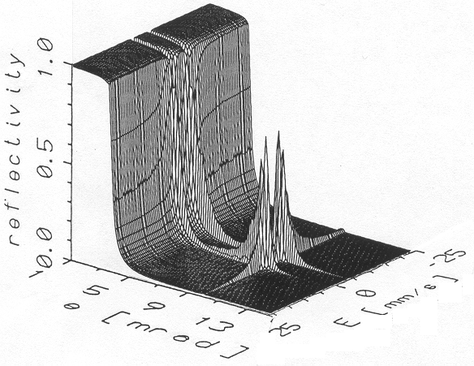
Figure 1
Energy-domain reflectivity of ⁵⁷Fe/⁵⁶Fe multilayer
Figure 2
Reflectivity curves at resonant (E= 3.072 mm/s, dashed line) and at E =5 mm/s (solid line)
Figure 3
Mössbauer spectrum at the Bragg position (θ = 10.123 mrad)
MR is a unification of reflectometry and Mössbauer spectroscopy. Indeed, taking the cross-sections at fix energies E on Fig. 1, we get reflectometry spectra, as shown on Fig. 2. For the given energies E having the index of reflection n from the expression of Lax [Error: Reference source not found] and using the optical picture [Error: Reference source not found,Error: Reference source not found], reflectometry spectra can be calculated as generalized Fresnel- formulae [Error: Reference source not found,Error: Reference source not found]. Because of the isotropic periodicity we have a Bragg-peak at θ = 10.123 mrad on Figs 1 and 2 for energies near the resonance. Far from the resonances, however, only the electronic scattering has considerable probability, so the spectrum is the x-ray reflectivity curve. From point of view of electronic scattering, the isotopic structure does not give any contrast, and the Bragg-peak disappears. On the other part, taking the cross-sections at fix grazing angles θ we get the energy dependent Mössbauer spectra (Fig 3). In the model, the hyperfine field was parallel to the surface of the multilayer and transversal electric (TE), viz. σ-polarized, incident beam was assumed. In this special case there are only two Mössbauer lines at E = ±3.072 mm/s. The broadening and asymmetry of the individual lines are caused bye the multiple scattering and the strong dispersion near the nuclear resonance; furthermore the asymmetry between the lines are caused by the electronic scattering.
Using SR as source, the simultaneous broadband coherent excitation results time-domain SMR spectra, those are the Fourier-transformed of the complex energy-domain reflectivity curves, as shown on Fig. 4. The TDSMR spectra, we measure (Fig. 5), are the cross-sections at fix grazing angle θ of the two-dimensional surface on Fig. 4. TISMR means integration of the TDSMR spectra from t₁ to t₂ as a function of θ, where t₁ and t₂ define fix time interval (Fig. 6), as it was explained in the previous paragraphs.
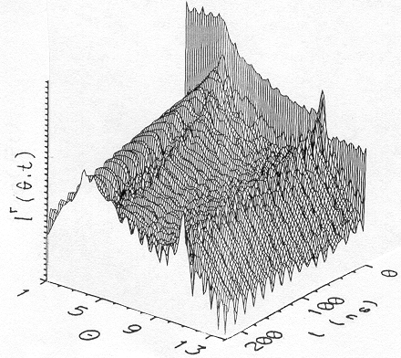
Figure 4
Time-domain reflectivity spectrum of ⁵⁷Fe/⁵⁶Fe multilayer

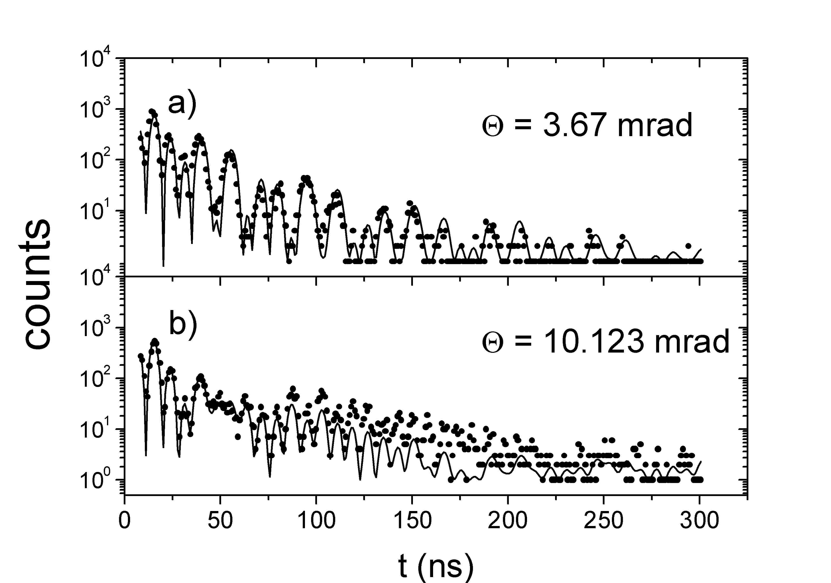
Figure 5
Experimental and theoretical TDSMR spectra of ⁵⁷Fe/⁵⁶Fe multilayer at θ = 3.67 mrad (near the critical angle) (a) and at θ = 10.123 mrad (Bragg position) (b).

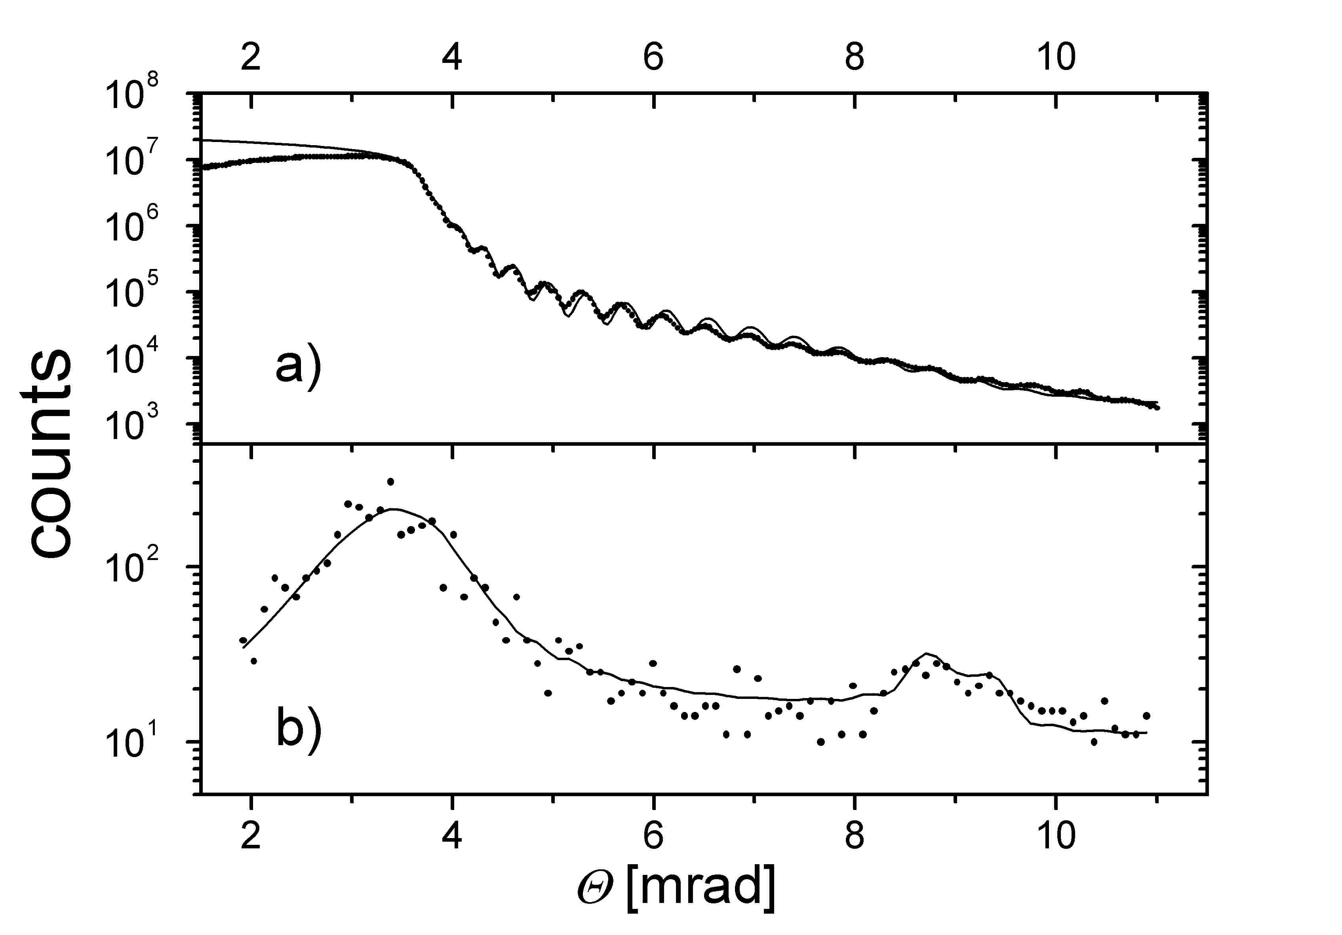
Figure 6
Non-resonant x-ray reflectivity (a) and TISMR (b) spectra of ⁵⁷Fe/⁵⁶Fe

On the TISMR spectrum (Fig 6) we also see the Bragg peak (θ = 9 mrad) [] and an additional peak at the critical angle, θ = 3.67 mrad, this latter being the interference effect of the electronic a nuclear scattering of photons [Error: Reference source not found,Error: Reference source not found]. There is no Bragg peak on the x-ray reflectivity curve [Fig 6], as it was explained earlier.

3. The theory of SMR
In this section, starting from the general theory of Lax [Error: Reference source not found], we shall obtain some general formulae for the scattering of multicomponent waves []. Description the theories of the various scattering processes on a single scatterer lead to an inhomogeneous wave equation
$\left[\left(Δ+k^{2}\right)I−U\left(r\right)\right]Ψ_{1}\left(r\right)=0$ (1)
where k is the vacuum wave number, I is the unit matrix, $U\left(r\right)$ is the scattering potential and $Ψ_{1}\left(r\right)$ is the amplitude of the scattered wave, an electromagnetic field vector or quantum mechanical spinor state. For many scattering centers the coherent field $Ψ\left(r\right)$ fulfils the
$\left[\left(Δ+k^{2}\right)I+4πN\bar{f}\right]Ψ\left(r\right)=0$ (2)
three-dimensional wave equation, where $\bar{f}$is the coherent forward scattering amplitude, N is the density of the scattering centers per unit volume and $Ψ\left(r\right)$ is the coherent field defined by an average of the field vectors over the positions and states of the scattering centers [Error: Reference source not found]. Eq. (2) shows that from the point of view of the coherent field the system of randomly distributed scattering centers can be replaced by a homogeneous medium, with an index of refraction $n=I+\frac{2πN}{k^{2}}\bar{f}$. Since n for both x-rays and slow neutrons hardly differs from I, it is better to use the susceptibility tensor defined by $χ≡\frac{4πN}{k^{2}}\bar{f}$ [Error: Reference source not found].
By choosing a simple homogeneous layer with the above susceptibility χ and z-axis normal to the layer, one gets the 1D wave equation:
$Ψ\text{''}\left(z\right)+k^{2}\text{sin}θ \left[I\text{sin}θ+\frac{χ}{\text{sin}θ}\right]Ψ\left(z\right)=0$ (3)
with θ being the angle of incidence. Defining $Φ\left(z\right)$ via $\left(\text{ik}\text{sin}θ\right)Φ'\left(z\right)≡Ψ\text{''}\left(z\right)$, we get a system of first order differential equations:
$\frac{d}{dz}\left(\begin{matrix}Φ \\ Ψ\end{matrix}\right)=\text{ikM}\left(z\right)\left(\begin{matrix}Φ \\ Ψ\end{matrix}\right)$, (4)
where
$M\left(z\right)=\left(\begin{matrix}0 & I\text{sin}Θ+\frac{χ}{\text{sin}θ} \\ I\text{sin}θ & 0\end{matrix}\right)$. (5)
is commonly called the ''differential propagation matrix'' in optics [Error: Reference source not found,Error: Reference source not found]. Eq. (4) was derived without specifying the scattering process.
For an arbitrary multilayered film with homogenous layers of thicknesses d₁,d₂,…,d_{S} and differential propagation matrices M₁,M₂...M_{S}, χ in Eq. (5) is replaced by the susceptibility $χ_{l}$of layer l. The solution of the differential equation (4) can be expressed in terms of the total characteristic matrix
$L=L_{s}⋅\text{.}\text{.}\text{.}⋅L_{2}⋅L_{1}$ (6)
of the multilayer, where
$L_{l}=\text{exp}\left({\text{ikd}}_{l}M_{l}\right)$ (7)
is the characteristic matrix of the l^{th} individual layer. The $2×2$ reflectivity matrix R is calculated from the total characteristic matrix L by
$R={\left[L^{\left[\text{11}\right]}−L^{\left[\text{12}\right]}−L^{\left[\text{21}\right]}+L^{\left[\text{22}\right]}\right]}^{−1}\left[L^{\left[\text{11}\right]}+L^{\left[\text{12}\right]}−L^{\left[\text{21}\right]}−L^{\left[\text{22}\right]}\right]$. (8)
where $L^{\left[\text{ij}\right]}$ (ij=1,2) are $2×2$ blocks of the $4×4$ total characteristic matrix L [Error: Reference source not found]. The reflected intensity
$I^{r}=\text{Tr}\left[R^{+}Rρ\right],$ (9)
can be calculated by using the arbitrary polarization density matrix ρ of the incident beam and the reflectivity matrix [Error: Reference source not found].
We would like to note, that the starting point of Lax, viz. Eq. (1), is not a trivial assumption for photons, because the susceptibility χ is generally $3×3$tensor in the Maxwell theory, which can not be directly expressed by the $2×2$ coherent forward scattering length $\bar{f}$. This problem was treated in Ref. [Error: Reference source not found].
4. Numerical Considerations
The numerical problem in evaluating the reflectivity is the calculation of the exponential of the $4×4$ matrices in Eq. (7). Here we cite our previous results [Error: Reference source not found] proving that it is possible to get a closed solution to the general problem requiring the calculation of $2×2$ matrices only. The characteristic matrix is of the form
$L_{l}=\left(\begin{matrix}\text{cosh}\left(F_{l}\right) & \frac{1}{x_{l}}F_{l}\text{sinh}\left(F_{l}\right) \\ x_{l}F_{l}^{−1}\text{sinh}\left(F_{l}\right) & \text{cosh}\left(F_{l}\right)\end{matrix}\right)$, (10)
where the $2×2$ matrix $F_{l}=\text{kd}\sqrt{−I{\text{sin}}^{2}θ−χ_{l}}$ and $x_{l}={\text{ikd}}_{l}\text{sin}θ$ [Error: Reference source not found].
To evaluate Eq. (10), first we have to calculate the $2×2$ square root of the F matrices. This can be made by using the identity
$G^{1/2}=\frac{G+I\sqrt{\text{det}G}}{\sqrt{\text{Tr}G+2\sqrt{\text{det}G}}}$ (11)
where G is any non-diagonal $2×2$ matrix [Error: Reference source not found]. The sinh and cosh functions are calculated from their definition with the exponential functions. Moreover, the exponential of the $2×2$ matrix G can be expressed by itself and its scalar invariants:
$\text{exp}G=\text{exp}\left(\frac{1}{2}\text{Tr}G\right)\left[\text{cos}\sqrt{\text{det \{}\bar{G}} | | I+\frac{\text{sin}\sqrt{\text{det \{}\bar{G}}}{\sqrt{\text{det \{}\bar{G}}} | | \sqrt{\bar{G}}\right],$ (12)
where $\bar{G}=G−\frac{1}{2}I\text{Tr}G$ [Error: Reference source not found].
In order to calculate the characteristic matrix of a semi-infinite layer (substrate) S, we have to find its $L_{s}→L^{∞}$ limes for $d_{s}→∞$. From Eqs. (5) through (12) follows that the corresponding limes is given by
$L^{∞}=\left(\begin{matrix}I & a\sqrt{I+\frac{χ_{s}}{{\text{sin}}^{2}θ}} \\ a{\left(\sqrt{I+\frac{χ_{s}}{{\text{sin}}^{2}θ}}\right)}^{−1} & I\end{matrix}\right)$, (13)
where $a=\text{sgn}\left[\text{Re}\left(\text{Tr}F_{∞}\right)\right]$ is the sign of the real part of the trace of $F_{∞}=\sqrt{−I{\text{sin}}^{2}θ−χ_{s}}$
The above algebra turns out to be numerically very stable; therefore this approach is suitable for fast numerical calculations of the characteristic matrices for anisotropic stratified media. In fact, the exponential of the matrix in Eq. (5) can be calculated exactly without solving any eigenvalue problem. Because of the underlying common optical approach the same theory can be applied for SMR, x-ray reflectometry, spin polarized neutron reflectometry [Error: Reference source not found] and x-ray resonance exchange scattering [,]. The computer program EFFI (Environment For FItting) based on this calculus is freely available [Error: Reference source not found,].
5. Heterodyne detection
Coussement et al. suggested the heterodyne detection of nuclear resonant forward scattering of SR [Error: Reference source not found,Error: Reference source not found]. To avoid the difficulties of the numerical Fourier transformation, they calculated directly in the energy-domain [Error: Reference source not found,Error: Reference source not found,Error: Reference source not found]. Making the necessary generalizations corresponding to SMR we repeat the same calculations. In the forward scattering case to calculate the transmission T_{r} through the reference layer we use the Blume-Kistner theory [Error: Reference source not found], for the reflection geometry to calculate the reflectivity R from the multilayer we apply Eq. (8). To take into account any possible polarization of the incident beam we apply the intensity form Eq. (9).
In the experimental setup of heterodyne detection two absorbers were used, the investigated one and an additional single line Mössbauer absorber acting as reference sample. The reference sample is mounted on a Mössbauer drive and the total number of delayed forward scattered γ-photons are detected as a function of Doppler velocity v of the reference layer [Error: Reference source not found,Error: Reference source not found,Error: Reference source not found]. The energy-domain wave amplitude of the radiation at the detector is proportional to the product
T(ω,v) = T_{s}(ω)T_{r}(ω,v), (14)
where T_{s}(ω) and T_{r}(ω,v) are the transmission factors of the investigated and reference sample, respectively. If we apply this method for SMR experiments, the role of the reference layer will be the same and we get
T(ω,v,θ) = R(ω,θ)T_{r}(ω,v), (15)
as generalized transmissivity. Considering one synchrotron bunch only and using Eq. (9) the number of delayed counts is the integral of the time dependent intensity I(t,v,θ) for the time window defined by t₁ and t₂
$D\left(v,θ\right)=\int_{t_{1}>0}^{t_{2}<t_{\text{Bunch}}}{dt I\left(t,v,θ\right)}=\frac{Nτ}{2π}\int_{−∞}^{∞}{dtS\left(t\right)\text{Tr}\left[T^{+}\left(t,v,θ\right)T\left(t,v,θ\right)ρ\right]}$, (16)
where N is the number of photons in the incident bunch, τ is the duration of the synchrotron bunch (τ≈50 ps at ESRF), S(t) is the time window function defined by S(t)=1 for t₁<t<t₂, otherwise S(t)=0, t_{Bunch} is the time interval between the synchrotron bunches and
$T\left(t,v,θ\right)=\frac{1}{\sqrt{2π}}\int{dω \left[T\left(ω,v,θ\right)−T_{∞}\left(θ\right)\right]\text{exp}\left(iωt\right)}$ (17)
is the time-domain generalized transmissivity, with
$T_{∞}\left(θ\right)=R_{∞}\left(θ\right)T_{∞}$ (18)
being the generalized electronic (non resonant) transmissivity as the product of the electronic reflectivity $R_{∞}\left(θ\right)$ of the multilayer and the electronic transmissivity $T_{∞}$ of the reference sample. We note that in the forward scattering case the transmission factor T(ω,v) is proportional to the product of the electronic transmissivity of both, the reference and the investigated sample. In this special case only, the electronic scattering results in a simple normalization (absorption) factor in Eq. (18), so one can calculate with the clear nuclear transmissivities replacing $T_{∞}=1$. This kind of consideration was used in Refs. [Error: Reference source not found,Error: Reference source not found,Error: Reference source not found]. In the SMR geometry, however, the electronic scattering plays important role and we have to calculate with the given form of Eq. (17) using the correct value of the angular dependent$T_{∞}\left(θ\right)$.
For the real periodic bunch structure of the synchrotron, we have to extend the time window function S(t) as periodic function of time t, with $t_{\text{Bunch}}=\frac{2π}{Ω}$ periodicity of the bunches. Because the duration of the synchrotron pulse τ is ten order of magnitudes grater, then the typical period time of the γ-radiation; and three order of magnitudes less (in case of ⁵⁷Fe) then the life time of the exited nuclear states, one can add incoherently the contributions from the different bunches. In this case one can expand the periodic time window function
$S\left(t\right)=\sum_{n=−∞}^{∞}{S_{n}\text{exp}\left(\text{in}Ωt\right)}$ (19)
in Fourier series [Error: Reference source not found] and using Eqs. (16), (17) and (19), we get the counts rate
$\tilde{D}\left(v,θ\right)=N\frac{τ}{t_{\text{Bunch}}}\sum_{n=−∞}^{∞}{S_{n}\int_{−∞}^{∞}{dω\text{Tr}\left\{\left[T^{+}\left(ω+nΩ\right)−T_{∞}^{+}\right]⋅\left[T\left(ω\right)−T_{∞}\right]ρ\right\}}}$, (20)
where we dropped the notation of the v and θ dependence of the right side.
If we had the full time range, we could apply the Parseval theorem in Eq (16) and we could perform the integral in the energy-domain, which would give the aria under the Mössbauer lines. Using the experimental setup of the heterodyne method [Error: Reference source not found,Error: Reference source not found,Error: Reference source not found], one expect a constant (viz. independent from the Doppler velocity v) baseline for cases the absorption lines of the investigated sample and the absorption line of the reference sample do not overlap, otherwise we expect interference between the two sample. The maximum interference we receive, when the aria under the Mössbauer lines of the investigated sample equals the aria under the Mössbauer line of the reference layer. In the forward scattering case this integral condition fulfills when the effective thickness of the two samples equals, resulting in constructive interference at the resonance lines of the investigated sample in the heterodyne spectrum. In SMR we have to use the integral criteria, because there is no analogy of the effective thickness. Fig 1 shows one more interesting difference. For grazing angles, being smaller then the critical angle we have absorption like resonances, which agrees with the nature of forward scattering spectra. If the grazing angle is grater then the critical angle we have emission like MR spectra, therefore we may also get destructive interference.
Using realistic periodical time window, one has to consider the effect of the sum in Eq (20) that provides the stroboscopic resonances in the heterodyne spectrum [Error: Reference source not found]. Indeed, in Eq (20) for a given stroboscopic order n the Doppler velocity v can compensate the shift $nΩ$ in the argument of $T^{+}\left(ω+nΩ\right)$ providing additional resonances at certain velocities v [Error: Reference source not found]. From this point of view there is no difference between the SMR and the forward scattering geometry.
For calculating stroboscopic SMR spectra we used Eq. (20) with our data evaluation program EFFI [Error: Reference source not found,Error: Reference source not found]. In the next section we discuss the corresponding results.

6. Model simulations
The first simulations were done in forward scattering geometry to reproduce the results of Ref [Error: Reference source not found]. Unlike the time differential method, the heterodyne detection gives spectra in the energy-domain, and we can now demonstrate some interesting differences between the two approaches. Fig. 7 shows the simulated stroboscopic and time differential spectra of an α-⁵⁷Fe foil for different incoming polarizations, and for the case the direction of the hyperfine magnetic field B_{Hf} being parallel to the propagation of the SR. In this case, the left circularly polarized incident beam can excite only the 1st and the 4th Mössbauer lines; the right circularly polarized beam excites the 3rd and the 6th lines of iron, additionally an incident σ-polarized beam excites all the four lines (1, 3, 4 and 6), because one can compose the σ-polarization as linear combination of left and right circularly polarized waves. The stroboscopic spectra on Fig 7 show this fact. We note, that we see the n = 0 and the n = ±1 stroboscopic orders together on the figure. On the other hand the time differential spectra are identical, not depending on the polarization, because the distance of the 1st and 4th lines equals the distance of the 3rd and 6th lines giving only phase difference in the time spectra, and the left and right polarizations being orthogonal to each other, this phase shift can not be observed.
The complementary of the previous example is shown on Fig 8. Here we calculated the time differential and the stroboscopic spectra of two α-⁵⁷Fe foils, having parallel and anti-parallel hyperfine magnetic fields B₁ and B₂ relative to each others, in the direction of the propagation of the SR. Using σ-polarized incident beam, we can easily distinguish between the parallel and antiparallel orientations on the time differential spectra, but the stroboscopic spectra only hardly differ. In the energy-domain we see all the four lines for both cases, parallel or antiparallel orientation, therefore the spectra are similar. In the time domain, however, the parallel orientation is equivalent with the previous example; in fact we have a two times thicker α-⁵⁷Fe foil and we see the fingerprint of two Mössbauer lines resulting one frequency. For antiparallel orientation all the four lines have role and the beating is according the four lines, which makes large difference on Fig. 8.
Discussing the feasibility of stroboscopic SMR, we return to the isotopic periodical ⁵⁷Fe/⁵⁶Fe multilayer, the model system that was described in section 3 and in Ref. [Error: Reference source not found]. Fig. 9 shows the TISMR spectra for different orientations of the hyperfine field B_{Hf}. It follows, that in TDSMR and stroboscopic SMR experiments we expect the maximal count rates at the critical angle, θ = 3.67 mrad. The Bragg peak provides an additional local maximum in the count rate, but it has lower intensity by one order of magnitude. Fig. 10 shows the energy-domain MR and stroboscopic SMR simulations at different grazing angles. For grazing angles less then the critical angle (θ < 3.67 mrad) the stroboscopic SMR spectra are similar to the forward scattered spectra [Error: Reference source not found], there are peaks at the n = 0 (0th order stroboscopic resonance) and absorption-like lines at the n = ±1 (1st order stroboscopic resonances). The nature of the spectra changes after the critical angle, and we have absorption-like lines at the center of spectra, and emission-like peaks for the n = ±1 stroboscopic orders (see θ = 10.6 mrad, on Fig. 10), as it was explained in the previous section.
The next important question is the choice of the reference layer. We calculated the stroboscopic SMR spectra at the Bragg position using different reference layers on Fig. 11. The effect is better for the thicker reference layers, but we lost the energy resolution. Indeed, the two Mössbauer lines at v = ±3.072 mm/s start overlapping at grater effective thichness (T_{eff} > 40). Having too thick reference layers the high electronic absorption also makes experimental problems. We used the integral criteria around the critical angle to find the angular dependent optimal effective thickness of the reference layer (Fig. 12). This shows, that we cannot reach definitely the optimal effective thickness T_{eff} = 550 at the critical angle, because of the electronic absorption and the bad energy resolution. We note, that the electronic absorption of a α-⁵⁷Fe foil of 10 μm (T_{eff} = 150) is about 40%.
To calibrate the intensities, we used the experimental results explained on Fig. 2c of Ref. [Error: Reference source not found]. Using the same parameters we recalculated the spectrum taking into account the electronic absorption of the reference layer (T_{eff} = 41) and we normalized to the number of counts to 625, that was observed after the 20 min of measurement. Having the calibration factor we simulated the stroboscopic SMR spectra at different grazing angles. Fig. 13 shows that we have acceptable intensity even at the Bragg position. The tendency of the baselines follows rule of the TISMR spectra (Fig. 9).
SMR is used for studying multilayer and thin films. In case of magnetic layers the most important information is usually the orientation of the hyperfine magnetic field. The sensitivity of stroboscopic SMR to the direction is critical point of the applicability. We calculated the stroboscopic SMR spectra at the Bragg position for different orientations of the hyperfine field on Figs. 14, 15 and 16, with t_{Bunch} = 140 ns, 8 ns and 4 ns, respectively. The figures show, that one can easily distinguish between the different orientations.
The last example we discuss the case of anti-ferromagnetic (AF) multilayers. SMR yields information on the alignment of the individual sublayer magnetization, as well. Having multilayer with AF coupling between the Fe layers, depending on the geometry, the TISMR spectra may reveal the magnetic multilayer period doubling, which results in an additional Bragg peak, called AF-Bragg peak. Fig. 17 shows the corresponding TISMR spectra of ⁵⁷Fe/Cr AF multilayer for two different orientation of the hyperfine filed, B_{Hf} being parallel to the propagation of the SR (direction k) and B_{Hf} parallel to the direction of the σ-polarization (perpendicular to k). Both TISMR spectra have the peak at the critical angle (θ = 3.67 mrad) and the structural Bragg peak (at θ = 12.04 mrad), latter being the result of the electronic contrast between the Fe and Cr layers. Unlike the isotopic periodical ⁵⁷Fe/⁵⁶Fe multilayer the structural Bragg peak also would appear on the x-ray reflectivity curve, because of the electronic contrast. In the case of B_{Hf} being parallel to the direction of the σ-polarization, or in general for any orientation being perpendicular to k, there is no AF-Bragg peak at θ = 6.81 mrad. The reason of this is the special angular dependence of the coherent forward scattering amplitude $\bar{f}$ [see also Eq. (3)]. To have an AF-Bragg peak one need contrast in the susceptibilities according to the AF symmetry. The only contribution in $\bar{f}$ may result contrast is the cosine function of the angle of k and B_{Hf} [Error: Reference source not found,], that is the same 90 degree for any direction perpendicular to k. Fig. 18 shows the TDSMR spectra for the same orientations, at the critical angle (θ = 3.67 mrad), at the AF-Bragg position (θ = 6.81 mrad) and at the structural Bragg position (θ = 12.04 mrad). At the AF-Bragg position there is two orders of magnitude difference in the intensities between the two orientations and the quantum beat structures also differ (Fig. 18). The stroboscopic SMR spectra on Fig. 19 show the same differences, so stroboscopic SMR is also capable for studying AF multilayers.
Summary
Theoretical and methodological overview of SMR was given. We generalized the concept of heterodyne/stroboscopic detection to SMR. Model calculations shows, that stroboscopic SMR provides acceptable intensities in real experiments. The optimal thickness of the reference layer is limited by the electronic absorption. Like TDSMR, stroboscopic SMR spectra are also sensitive to the direction of the hyperfine fields of the individual layers, so the method can be applied for studying AF multilayers and thin films..

Acknowledgements
It is a pleasure to thank helpful discussions with Prof. R. Coussement, R. Callens and I. Serdons, Katholike Universiteit Leuven. The financial support by the by the Flemish-Hungarian bilateral project BIL 98-20 is gratefully acknowledged.
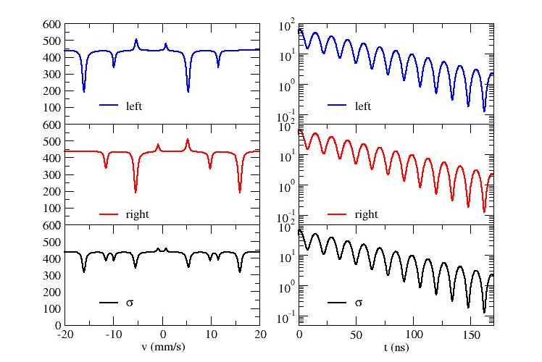
Figure 7
Stroboscopic detected and time differential nuclear resonant forward scattering spectra of α-⁵⁷Fe foil with different incident polarizations. The hyperfine magnetic field is parallel to the propagation of the synchrotron radiation.
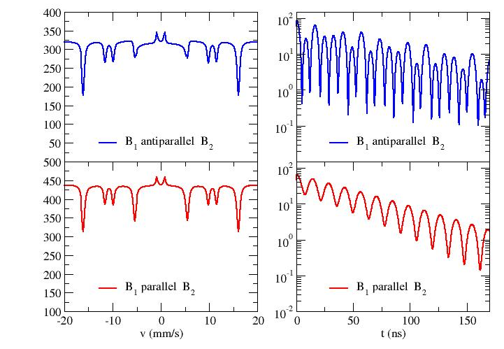
Figure 8
Stroboscopic detected and time differential nuclear resonant forward scattering spectra of two α-⁵⁷Fe foils excited by σ-polarized beam. The hyperfine magnetic fields B₁ and B₂ are antiparallel and parallel to each others.

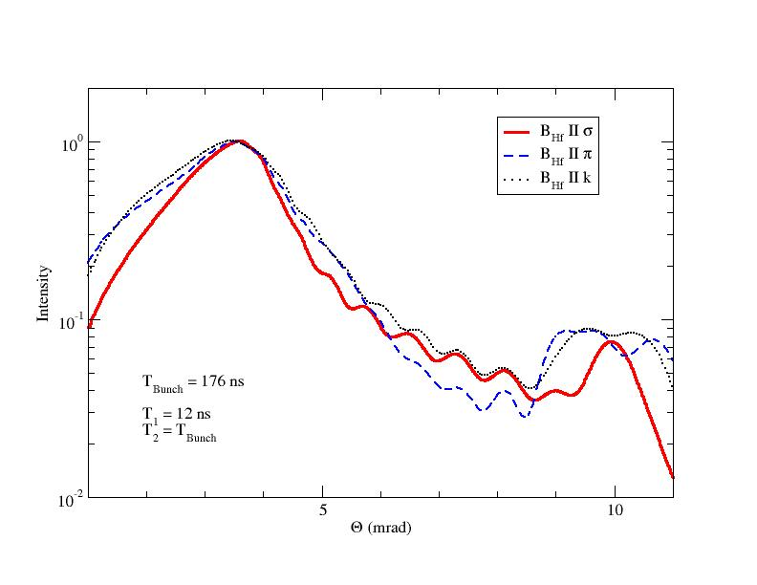
Figure 9
TISMR spectrum of ⁵⁷Fe/⁵⁶Fe multilayer for different orientations of the hyperfine magnetic field B_{Hf}.
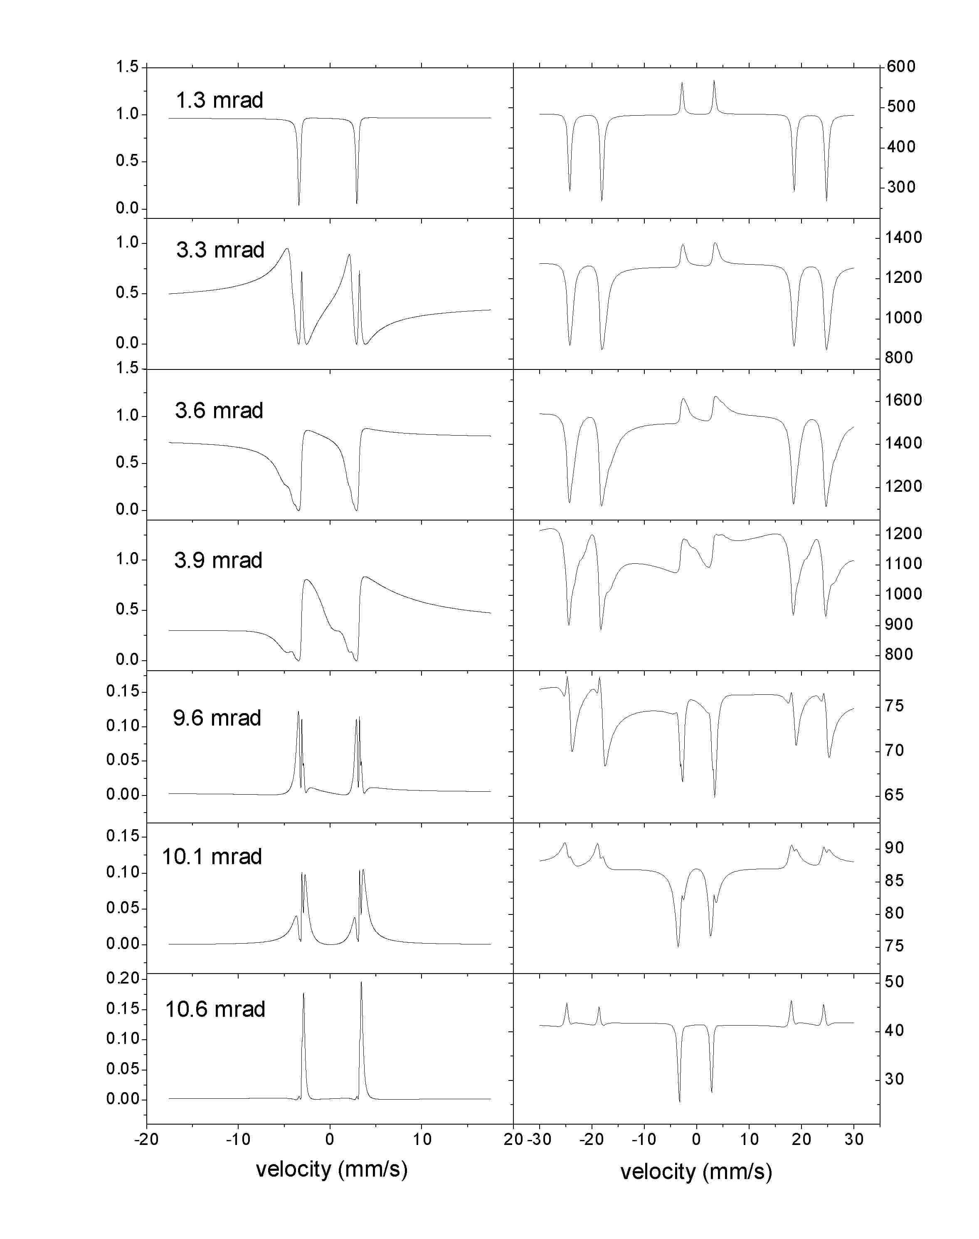
Figure 10
Energy-domain MR and stroboscopic SMR spectra of ⁵⁷Fe/⁵⁶Fe multilayer at different grazing angles. t_{Bunch} = 4 ns, B_{HF} perpendicular to the synchrotron ring.
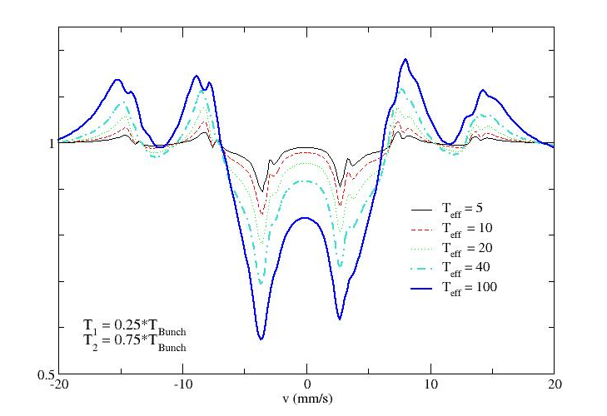
Figure 11
Stroboscopic SMR spectra of ⁵⁷Fe/⁵⁶Fe multilayer at the Bragg position. The effective thickness of the reference layer .was changed from T_{eff} = 5 to T_{eff} = 100
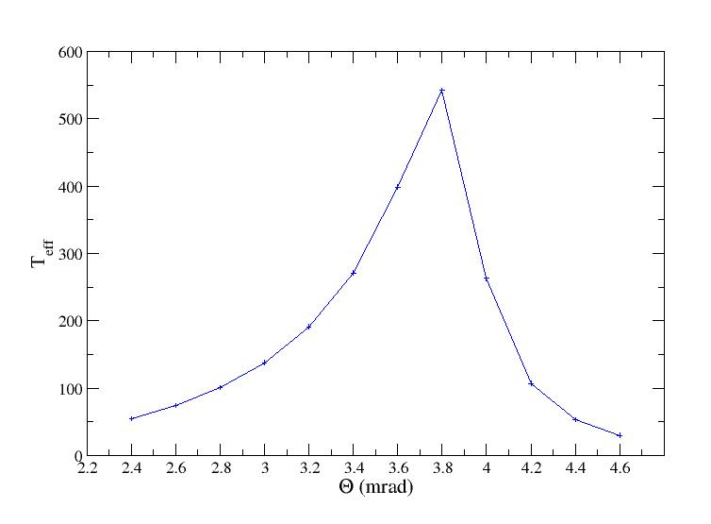
Figure 12
Optimal effective thickness of the reference layer calculated from the integral criteria near the critical angle in discrete points.

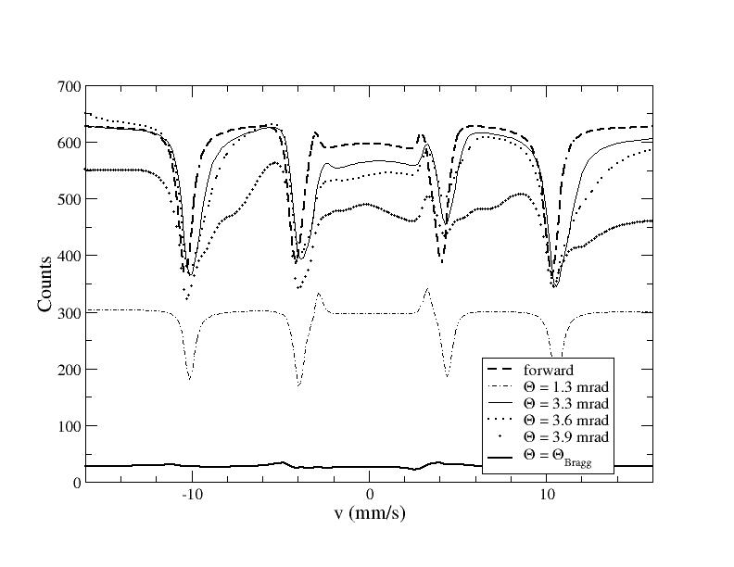
Figure 13
Comparison of baselines and intensities of stroboscopic forward scattered spectrum of ⁵⁷Fe foil (dashed line) with stroboscopic SMR spectra of ⁵⁷Fe/⁵⁶Fe multilayer simulated at different grazing angles.

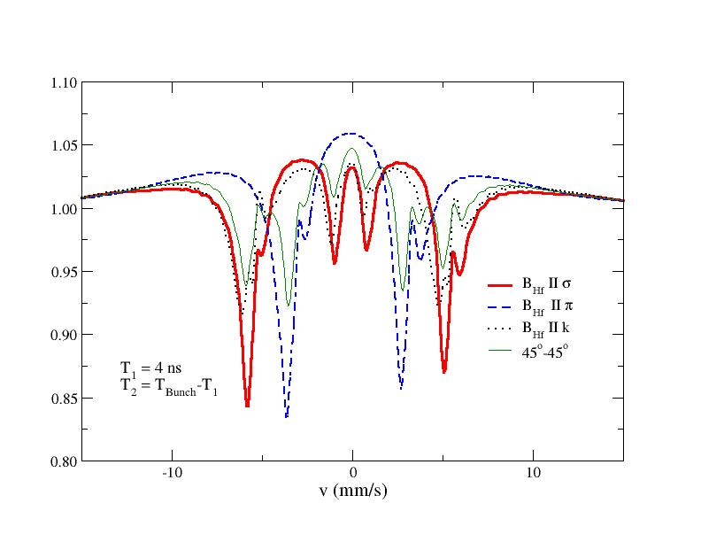
Figure 14
Stroboscopic SMR spectra of ⁵⁷Fe/⁵⁶Fe multilayer at the Bragg position with different orientations of the hyperfine magnetic field. t_{Bunch} = 140 ns

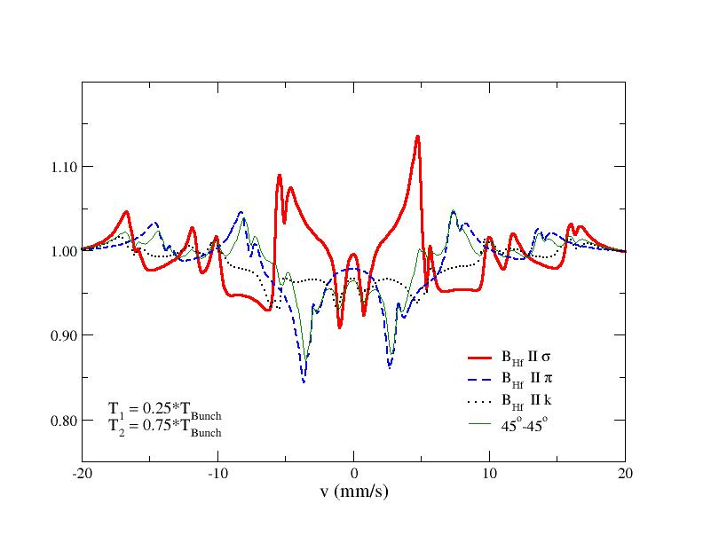
Figure 15
Stroboscopic SMR spectra of ⁵⁷Fe/⁵⁶Fe multilayer at the Bragg position with different orientations of the hyperfine field. t_{Bunch} = 8 ns

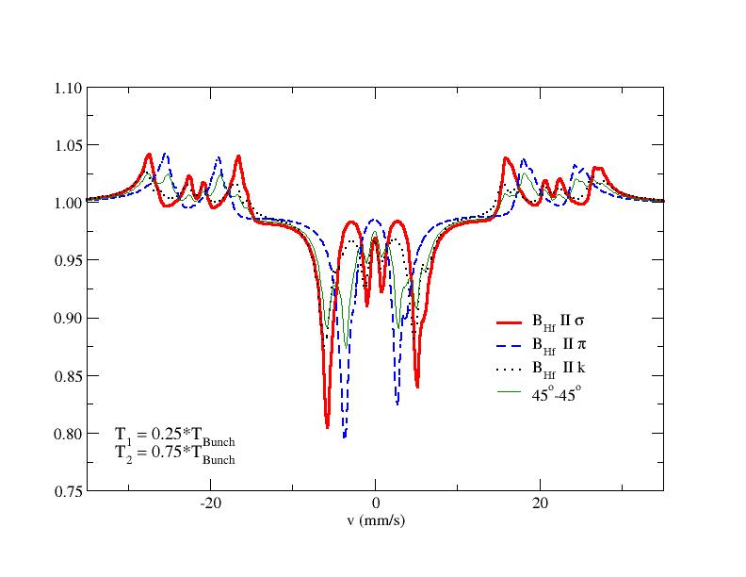
Figure 16
Stroboscopic SMR spectra of ⁵⁷Fe/⁵⁶Fe multilayer at the Bragg position with different orientations of the hyperfine field. t_{Bunch} = 4 ns

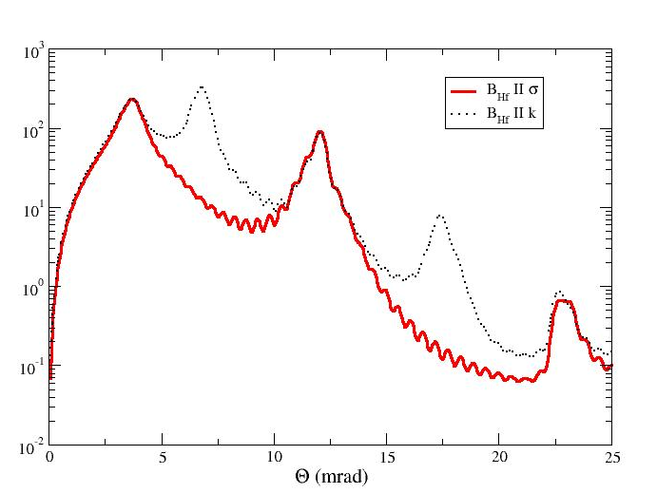
Figure 17
TISMR spectra of ⁵⁷Fe/Cr AF multilayer for different orientations of the hyperfine field.

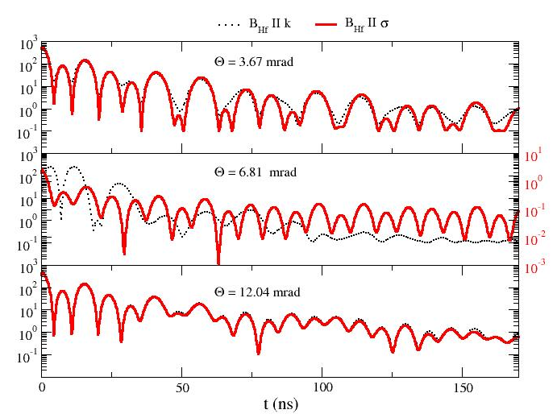
Figure 18
TDSMR spectra of ⁵⁷Fe/Cr AF multilayer for B_{Hf} parallel to the wave vector k (dotted line) and B_{Hf} parallel to the σ-polarization (solid line) at three different grazing angles. The right side axis corresponds to the B_{Hf} parallel to direction of the σ-polarization case at the AF-Bragg position, where having no AF-Bragg peak, the intensity is by two orders of magnitude lower.

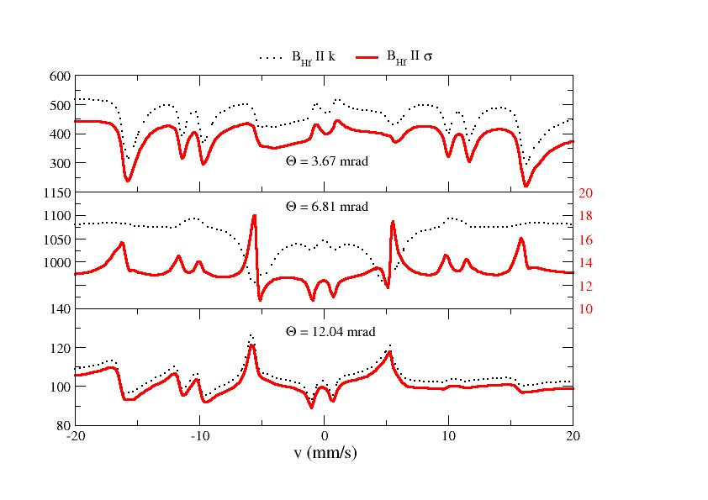
Figure 19
Stroboscopic SMR spectra of ⁵⁷Fe/Cr AF multilayer for B_{Hf} parallel to the wave vector k (dotted line) and B_{Hf} parallel to the σ-polarization (solid line) at three different grazing angles. The right side axis corresponds to the B_{Hf} parallel to direction of the σ-polarization case at the AF-Bragg position, where having no AF-Bragg peak, the intensity is by two orders of magnitude lower.

[?] M. Lax, Rev. Mod. Phys. 23 (1951) 287.
[?] M. Blume and O. C. Kistner, Phys. Rev. 171 (1968) 417.
[?] S. Bernstein and E.C. Campbell, Phys. Rev. 132 (1963) 1625.
[?] D.L. Nagy and V.V. Pasyuk, Hyp. Int. 71 (1992) 1349.
[?] S.M. Irkaev, M.A. Andreeva, V.G. Semenov, G.N. Belozerskii and O.V. Grishin, Nucl. Instrum. Methods B 74 (1993) 545.
[?] J. C. Frost, B. C. C. Cowie, S. N. Chapman, and J. F. Marshall, Appl. Phys. Lett. 47 (1985) 581.
[?] S. M. Irkaev, M. A. Andreeva, V. G. Semenov, G. N. Beloserskii, and O. V. Grishin, Nucl. Instrum. Methods B 74 (1993) 554.
[?] M. A. Andreeva, S. M. Irkaev, and V. G. Semenov, Sov. Phys.⎯JETP 78 (1994) 965.
[?] M. A. Andreeva and R. N. Kuz'min, Messbauerovskaya Gamma-Optika (Moscow University, 1982).
[?] M. A. Andreeva and K. Rosete, Poverkhnost' 9 (1986) 145; Vestnik Mosk. Univ., Ser. 3. Fiz. Astron. 27 (1986) 57.
[?] A. M. Afanas'ev and Yu. Kagan, Sov. Phys. ⎯JETP 21 (1965) 215.
[?] G. M. Borzdov, L. M. Barskovskii, and V. I. Lavrukovich, Zh. Prikl. Spektrosk. 25 (1976) 526.
[?] F. I. Fedorov, Teoria Girotropii (Nauka i Technika, Minsk, 1976).
[?]L. Deák, L. Bottyán, D.L. Nagy and H. Spiering, Phys. Rev. B. 53 (1996) 6158.
[?] H. Spiering, L. Deák, and L. Bottyán, Hyp. Int. 125 (2000) 197.
[?] J. P. Hannon and G. T. Trammell, Phys. Rev. 169 (1968) 315.
[?] J. P. Hannon and G. T. Trammell, Phys. Rev. 186 (1969) 306.
[?] J. P. Hannon, N. V. Hung, G. T. Trammell, E. Gerdau, M. Mueller, R. Rüffer, and H. Winkler, Phys. Rev. B 32 (1984) 5068.
[?] J. P. Hannon, G. T. Trammell, M. Mueller, E. Gerdau, R. Rüffer, and H. Winkler, Phys. Rev. B 32 (1985) 6363.
[?] R. Röhlsberger, Ph.D. thesis, University Hamburg, 1994.
[?] R. Coussement, S. Cottenier, and C. L’abbé, Phys. Rev. B 54 (1996) 16003.
[?] C. L’abbé et al., Phys. Rev. B 61 (2000) 4181.
[?] R. Callens, R. Coussement, C. L’abbe, S. Nasu, K. Vyvey, T. Yamada, Y. Yoda, and J. Odeurs, accepted by Phys. Rev. B
[?] D.L. Nagy, L. Bottyán, L. Deák, J. Dekoster, G. Langouche, V.G. Semenov, H. Spiering and E. Szilágyi, in: Mössbauer Spectroscopy in Materials Science, eds. M. Miglierini and D. Petridis (Kluwer Academic Publishers, 1999) p.323.
[?] A.I. Chumakov, L. Niesen, D.L. Nagy and E.E. Alp, in: Nuclear Resonant Scattering of Synchrotron Radiation, eds. E. Gerdau and H. de Waard (Baltzer Science Publishers, special volume of Hyp. Int.) in press.
[?] M. Grote, R. Röhlsberger, M. Dimer, E. Gerdau, R. Hellmich, R. Hollatz, J. Jäschke, E. Lüken, J. Metge, R. Rüffer, H.D. Rüter, W. Sturhahn, E. Witthoff, M. Harsdorff, W. Pfützner, M. Chambers and J.-P. Hannon, Europhys. Lett. 14 (1991) 707.
[?] A.I. Chumakov, G.V. Smirnov, A.Q.R. Baron, J. Arthur, D.E. Brown, S.L. Ruby, G.S. Brown and N.N. Salashchenko, Phys. Rev. Lett. 71 (1993) 2489.
[?] E.E. Alp, T.M. Mooney, T. Toellner, W. Sturhahn, E. Witthoff, R. Röhlsberger, E. Gerdau, H. Homma and M. Kentjana, Phys. Rev. Lett. 70 (1993) 3351.
[?] A.Q.R. Baron, J. Arthur, S.L. Ruby, A.I. Chumakov, G.V. Smirnov and G.S. Brown, Phys. Rev. B 50 (1994) 10354.
[?] L. Deák, L. Bottyán and D.L. Nagy, Hyp. Int. 92 (1994) 1083.
[?] T.L. Toellner, W. Sturhahn, R. Röhlsberger, E.E. Alp, C.H. Sowers and E.E. Fullerton, Phys. Rev. Lett. 74 (1995) 3475.
[?] The Bragg position is different, because the model system differs by this measurement and simulation. The sample was: float glass/⁵⁷Fe(4.6 nm)/[⁵⁶Fe(2.9 nm)/⁵⁷Fe(2.3 nm)]15/Al(5.7 nm)
[?] L. Deák, L. Bottyán, D.L. Nagy, and H. Spiering, Physica B 297 (2001) 113.
[?] J.P. Hannon, G.T. Trammell, M. Blume, and Doon Gibs, Phys. Rev. Lett. 61 (1988) 1245.
[?] L. Deák et al., to be published (not yet implemented into our data evaluation program, EFFI)
[?] The computer program EFFI is available from ftp://iacgu7.chemie.uni-mainz.de/pub/effi
[?] R. Coussement, J. Odeurs, C.L’abbé, and G.Neyens, Hyp. Int 125 (2000) 113.

