MSPCA

MÖSSBAUER SPECTROSCOPY ORIENTED

PERSONAL COMPUTER ANALYZER

Description -------------------------------------------------------------------------------- 2

Technical Specification ------------------------------------------------------------------ 5

Software Performance ------------------------------------------------------------------- 8

Installation --------------------------------------------------------------------------------- 14

Version: 2.1 Date: 12/1/99

IMPORTANT!

Installation guide is on page 14.

MÖSSBAUER SPECTROSCOPY ORIENTED

PERSONAL COMPUTER ANALYZER

(MSPCA)

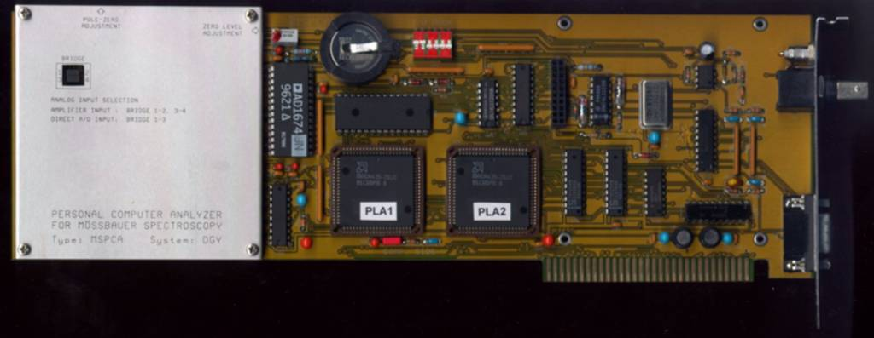

Multichannel analyzer basic card.

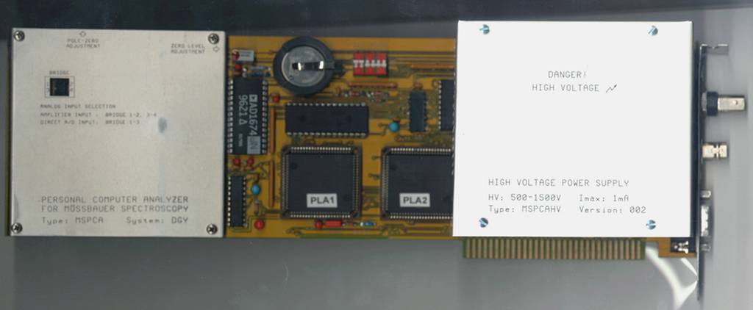

MSPCA card with optional on-board high voltage power supply.

The Mössbauer spectroscopy oriented analyzer card is basically a multichannel analyzer equipped with specialties for Mössbauer spectroscopy. The card is connectable to a PC ISA I/O slot.
Although the main goal was to construct a comfortable sophisticated Mössbauer analyzer, the card can meet the modest requirements of the gamma ray spectroscopy, too.

The card includes three important parts: a fast general purpose amplifier with computer controlled discrete gain values and single channel analyzer (SCA), a 4096 channel Analog to Digital Converter (ADC) and two programmable logic arrays with memory to realize the PHA (Pulse Height Analysis) and MCS (Multi-Channel Scaler) operation modes, and to build the interface between the card and PC.
In addition an optional High Voltage Power Supply module (MSPCAHV) can be plugged into the analyzer card, therefore a complete analog nuclear channel is available from the detector output.

The card with the standard software transforms the personal computer into a full featured Mössbauer spectroscopy analyzer. Any type of the Mössbauer function generators and driving units from different vendors is prompt connectable to the analyzer card (only two signals are expected from the Mössbauer units: channel dwell pulses and synchronising signals to start the MCS passes). The personal computer may include maximum 4 analyzer cards without HV power supplies or 2 cards with HV modules (supposed 4 ISA I/O slots on the PC main-board). The software handles max. 4 pieces of cards, one in the foreground, the others in the background.

The software is simple and user-friendly. The first screen contains the main menu: parameters to set, control functions, and to save/load spectra. The second screen displays the spectra (live spectra, 0.5 sec refresh cycles) and the actual parameters.

The minimum computer configuration: 1Mbyte memory, one floppy disk drive, any type of monitors. You can see that the oldest computer on the shelf can also be used. However we recommend to use a PC at least with 486 type main-board and color VGA monitor to exploit the software potentialities.

Different types of detectors can be connected to the analog signal input. The onboard amplifier and discriminators eliminate the conventional external AMP/SCA module usage.
The onboard amplifier can be set (gain, polarity, input termination) from the PC by the setup menu.
Scintillation detectors, proportional chambers, electron conversion detectors, etc. with any output polarity and amplitude can be used.
The onboard amplifier has high count-rate performance (max. 200kcps).
The lower and upper discriminator levels can be controlled from the PC, too. The user can adjust the discriminator levels in PHA mode continuously to gate the spectrum.

The optional high voltage module supplies the detectors from 500V to 1520V (jumper selectable + or - HV output polarity). The maximum output current is 1mA. The high voltage can be set on the PC from 500V to 1520V in 4V increments. Overload (>1.5mA) and overvoltage (>1700V) protections are built-in.

Fast 4096 channel analog/digital converter is used to process the analog input pulses in PHA mode.
Conversion time is less then 10 usec.
External TTL control pulses are available to enable or disable the conversion cycles for coincidence/anticoincidence measurements.
Direct converter input can be also used from the analog input by jumper setting.

The memory capacity for data storage is 32 Kbyte. The software can make partitions for 512, 1024, 2048 and 4096 channel sectors with 3 byte channel length (max. 16,777,215 counts/channel)

The memory is of a battery supported, nonvolatile type. In the case of line power failures, line power stoppage, the spectra are stored safely in the memory and they will not be lost.

Finally the figures 1--4 show the analyzer user screens. Figure 1. displays the main setup menu, figures 2. and 3. show a normal and gated amplitude spectrum, figure 4. shows a Mössbauer spectrum.

TECHNICAL SPECIFICATION

1./ AMPLIFIER PERFORMANCE
1.1/ SHAPING One stage differentiator , and active integrator shaping. Peak time: 1.5usec.
1.2/ INCOMING SIGNAL: UNIPOLAR, COUNT RATE max. 200K cps.
1.4/ GAIN RANGE from x5 to x200 in 6 discrete steps: x5, x10, x20, x50, x100, x200.
1.5/ POLE-ZERO ten-turn potentiometer for cancellation of decay times from 30us to infinity.
1.6/ INPUT POLARITY + or -.
1.7/ INPUT IMPEDANCE 1kohm (TERMINATION OFF) or 50 Ohm (TERMINATION ON).
1.8/ OUTPUT SIGNAL RANGE 0V to +5V.
1.9/ REAR PANEL CONNECTORS
AMP IN BNC connector for the detector or preamplifier output signal
AMP OUT MON LEMO connector for monitoring the amplified and shaped pulses

2./ SINGLE CHANNEL ANALYZER PERFORMANCE
2.1/ LOWER LEVEL DISCRIMINATOR LEVEL 0V to +5.1V digital control from 0 to 0xFF
2.2/ UPPER LEVEL DISCRIMINATOR LEVEL 0V to +5.1V digital control from 0 to 0xFF
2.3/ OUTPUT PULSE WIDTH 300nsec

3./ HIGH VOLTAGE POWER SUPPLY (OPTION)
3.1/ OUTPUT VOLTAGE from 500V to 1520V dc, software selectable in 4V increments
3.2/ OUTPUT POLARITY positive or negative, jumper selectable.
3.3/ OUTPUT CURRENT 0 to 1mA
3.4/ OUTPUT RIPPLE <50mV peak to peak (5Hz to 50Mhz)
3.5/ CALIBRATION INACCURACY < +/- 1% of setting
3.6/ OVERLOAD PROTECTION I>1.5mA (switch off)
3.7/ OVERVOLTAGE PROTECTION V>1700V (switch off)
3.8/ SLOW TURN-ON TURN-OFF 200V/sec
3.9/ TEMPERATURE RANGE 0 to 45 Celsius
3.10/ REAR PANEL CONNECTOR
HV OUT LEMO connector

4./ ANALOG/DIGITAL CONVERTER
4.1/ CHANNEL NUMBER 4096
4.2/ CONVERSION GAIN 4K, 2K, ..., 512.
4.3/ CONVERSION TIME less then 10usec
4.4/ INTEGRAL NONLINEARITY < +/-0.3%
4.5/ DIRECT CONVERTER INPUT FROM THE ANALOG AMP. INPUT (by jumper setting)
Analog input signal range 0V -- +5V.

5./ SPECTRUM MEMORY
5.1/ SIZE: 32Kbyte

5.2/ TYPE: low power consumption static RAM with battery support
5.3/ MEMORY ORGANIZATION: software configurable acquisition sectors.
512, 1024, 2048 or 4096 channel 4 byte depth acquisition sectors.
The fourth byte is reserved for parameter and comment storage.
Maximum counts per channel: 16,777,215 (Hex 0xFFFFFF)

6./ MCS (MULTICHANNEL SCALER) PERFORMANCE

6.1/ Max. count-rate for the scaler input: 500kcps
The minimum time between two pulses: 100nsec

Max. frequency for the scaler input: 5MHz
6.2/ External channel dwell pulses: TTL positive or negative pulse width: > 300nsec
External dwell time range: 20usec..INF.

6.3/ External synchronizing signals to start the passes: pulse width: > 300nsec
Positive or negative active edge software selectable
The active edge has to rise or fall during the dwell pulse

7./ CONNECTION (ALL CONNECTORS ON THE REAR PANEL)
7.1/ ANALOG INPUT: INPUT FOR THE AMPLIFIER OR DIRECT INPUT
FOR THE A/D CONVERTER (Jumper selectable). BNC Connector (AMP IN).
7.2/ AMP. MONITOR: Amplifier Output signal for monitoring.
LEMO Connector (AMP OUT MON).

7.3/ HIGH VOLTAGE OUTPUT (OPTIONAL): LEMO Connector
7.4/ 9 POINT DS TYPE CONNECTOR (EXTERNAL SIGNALS AND
INTERFACE FOR THE MÖSSBAUER SPECTROMETERS)

1. EXT. SYNC.: positive or negative TTL pulses to synchronize
the MCS passes to the Mössbauer Driving Systems' reference
signal that determines the waveform of the motion.
(input signal)

2. MCS DWELL : positive or negative TTL pulses for the channel advances
in MCS mode. (input signal)
3. GATE : SCA and A/D converter gate input signal (for coinc/anticoinc meas).
Positive or negative TTL pulses.
4. MCS IN: positive or negative TTL pulses for the counter input
in MCS mode. (input signal)
5. GND: GROUND.
6. UL OUT: upper level discriminator output signal
7. LL OUT: lower level discriminator output signal

8. SCA OUT: Single Channel Analyzer output signal
Positive or negative TTL pulses.

9. LIVE TIME: positive TTL level gate signals for live time periods
in PHA and MCS modes. (output signal)

8./ ONBOARD JUMPERS, SWITCHES

JP1 : ANALOG INPUT SELECTION: Amplifier or direct A/D conv. input
SW1 : PC I/O ADDRESS SELECTION. Default address: H300
HV POLARITY: POSITIVE OR NEGATIVE HIGH VOLTAGE OUTPUT SELECTION (on the optional MSPCAHV board)

9./ POWER REQUIREMENTS (without HV module)

+5V: 700 mA
+12V: 120 mA
-12V: 120 mA

10./ HV MODULE POWER REQUIREMENTS

+5V: 10 mA
+12V: 400 mA
-12V: 10 mA

11./ OPERATING TEMPERATURE
0 to 45 Celsius

SOFTWARE PERFORMANCE

The diskette which is shipped with the MSPCA analyzer card contains all the software necessary to operate the card. These softwares are running under an operating system such as MS-DOS or WINDOWS (as a DOS application). The user is responsible for loading the operating system.
The diskette contains files MSPCA.EXE, MSPCAM.EXE and MSPCA.CFG. MSPCA is a version for color monitors (EGA, VGA, SVGA), and MSPCAM for monochrome monitors (HERC., monochrome VGA). In addition you can find the files MSPCA1.EXE and MSPCAM1.EXE files on the diskette too. These files are intended for old type of PCs and are compiled with emulated mathematical co-processor option.
The MSPCA.CFG is a configuration file and stores all the card- and measuring- parameters. The configuration file can be updated by the user from the main menu. The parameters are also stored with the spectra in the spectrometer nonvolatile memory, and are refreshed by every measuring start.
Besides you can find the IOSPACE.EXE utility program to determine the free I/O address spaces in your PC and to help setting the I/O ADDR of the MSPCA board.

The software handles max. 4 spectrometer cards simultaneously, one in the foreground and the others in the background. In addition the user has the possibility to terminate the software after starting the measurements. In this case the spectrometer cards work alone until the user runs the software again. This is useful for long-time measurements if the user intends to free the PC for other tasks.

The software is simple: the first screen contains the main menu, the second screen displays the spectrum (live spectrum, 0.5 sec. refresh cycles) and the actual parameters.
The main menu includes two windows (Fig. 1.). In the upper window the user can select the actual cards (from 1 to 4) and their I/O port addresses. Further, in this window the configuration can be saved to the MSPCA.CFG file pressing the F5 function key.
The lower window contains a parameter setup menu of the current card, control functions, and commands to save/load spectra.

Parameter setup

Basic parameters:

MODE Selectable: PHA (Pulse Height Analysis) or MCS (Multi-Channel Scaler).
CHANNEL NUMBER Number of the channels for a spectrum. Selectable: 512, 1024, 2048 or 4096.
MEMORY GROUP Memory sector where the spectrum will be acquired. The max. sector number is 16 for 512 channels and 2 for 4096 channels.

Amplifier parameters:

AMPL. GAIN Gain range is variable from x5 to x200 in 6 discrete steps (5, 10, 20, 50, 100, 200).
AMPL. INPUT POL. Input-polarity selection : positive or negative.
AMPL. INP. TERM. Input-termination with 50 Ohm. Selectable ON or OFF.

High Voltage parameters:

HIGH VOLTAGE The high voltage output polarity is selectable on the HV module by jumper.
The high voltage output value is variable by software from 500V to 1520V in 4V increments. (horizontal ARROWS)
The high voltage ON/OFF is selectable by software. (CTRL + horizontal ARROWS)

Connected signals parameters:

EXT-SYNC POL. External pulses from the Mössbauer function generator are used to synchronize the MCS passes. TTL POSITIVE or TTL NEGATIVE input signal polarity is selectable.
EXT-DWELL POL. External dwell pulses from the Mössbauer function generator are used for channel stepping in MCS mode. TTL POSITIVE or TTL NEGATIVE input signal polarity is selectable.
MCS-IN POL. Multi-Channel-Scaler input polarity selection. Selectable TTL POSITIVE or TTL NEGATIVE input signal polarity.
SCA-OUT POL. Single-Channel-Analyzer output polarity selection. Selectable TTL POSITIVE or TTL NEGATIVE output signal polarity.
COINC./ANTICOINC. Coincidence/Anticoincidence selection. Selectable OFF, COINC, ANTIC. When OFF is selected, the GATE input has no effect on data acquisition. When COINC. is selected, a TTL high signal on the GATE input at time of peak-detection allows the event to be digitized and stored. A TTL low signal inhibits the A/D conversion and the SCA-OUT signal. When ANTIC. is selected, a TTL low signal on the GATE input at time of peak- detection allows the event to be digitized and stored. A TTL high signal inhibits the A/D conversion and the SCA-OUT signal. The GATE input signal has to be placed before the tailing edge of the lower level discriminator output signal (LL OUT). The setup time is min. 30 nsec, the hold time is min. 0 nsec.

Control functions

ACQUIRE Data acquisition start and stop selection (ON, OFF).
HIGH VOLTAGE High voltage switch-on and switch-off selection (ON, OFF).

Commands to save/load spectra

WRITE TO FILE Saves the selected spectrum to a file in ASCII form. The file contains one-line header part before the spectrum data, which is a user-written identification text and an automatic date/time&mode&channel stamp.
The ASCII file is a direct input file for Mössbauer spectrum processing programs (e.g. MOSSWINN or MMS), or can be reloaded at a future time.
READ FROM FILE Spectrum data that has been saved in a file in ASCII form may be loaded into the MSPCA analyzer, to display the spectrum, or to continue the acquisition.

The second screen displays the spectrum, the actual parameters and status information (Fig. 2.).
The parameters and status information are displayed at the left and bottom side of the screen. Control functions are also placed at the bottom side. Control functions are selectable by function keys from F1 to F6, shift+function keys and cursor keys.

Control functions

F1 : Data acquisition ON/OFF
SHIFT+F1: Clear spectrum

F2 : PHA/MCS mode selection
SHIFT+F2: An identification text may be entered up to 28 characters.

F3 : Channel number selection. Selectable: 512, 1024, 2048 or 4096.
SHIFT+F3: Memory sector selection where the spectrum will be acquired. The max. sector number is 16 for 512 channels and 2 for 4096 channels.

F4 : Preset type selection. Selectable: MINUTES, HOURS, KCPS (Kilo-Count-Per- Sec) and P.KCTS (Peak KCPS, peak parameters are marked by two cursors).
Time presets are according to real time.
SHIFT+F4: Preset value setting. Preset ranges are: from 0 to 9999 for MINUTES
from 0 to 9999 for HOURS
from 0 to 16777 for KCTS
from 0 to 16777 for P.KCTS
F5 : Functions in X (horizontal) direction.
Selectable: DSCR ON/OFF Discriminators are selected for ON/OFF setting.
DSCR LL Lower discriminator is selected for adjustment
by hor. arrows from 0 to 5100mV in 20mV steps.
Use Shift + hor. arrows for coarse adjustment.
DSCR UL Upper discriminator is selected for adjustment
by hor. arrows from 0 to 5100mV in 20mV steps.
Use Shift + hor. arrows for coarse adjustment.
CURS1 Cursor1 is selected to set by horizontal arrows.
Use Shift + hor. arrows for coarse adjustment.
CURS2 Cursor2 is selected to set by horizontal arrows.
Use Shift + hor. arrows for coarse adjustment.
SHIFT+F5: Setting the discriminators in ON or OFF states.

F6 : Vertical scale type selection.
Selectable: LOG Logarithmic scale
LIN Linear scale (min. size: 256, max. size: 16M)
The size is selectable by the vertical arrows from 256counts to 16Mcounts in 17 discrete values (x2)
AUTO Automatic scaling
vert. scale bottom: the minimum channel content
vert. scale top : the maximum channel content

Parameters and status information

DATE The current date
TIME The current time

CARD No. The number of the selected analyzer card

AMP. GAIN Gain of the amplifier
AMP. POL. Input polarity of the amplifier
AMP. TERM. Input termination (50 Ohm) of the amplifier

HV High Voltage parameters: polarity, value, ON/OFF state

CURSOR1 CHN Channel position of the first cursor
CURSOR1 CTS Channel content (Counts) at the first cursor position

CURSOR2 CHN Channel position of the second cursor
CURSOR2 CTS Channel content (Counts) at the second cursor position

DIFF Difference between the channel-contents pointed out by the two cursors
DIFF [%] Difference in percentage between the channel-contents pointed out by the two cursors. This is useful to show the efficiency of the Mössbauer effect.

ELAPS. TIME The elapsed time from the starting of the acquisition in hours and minutes.

CPS Pulse-rate during the acquisition in CPS (Counts-Per-Second).

IDENT. Spectrum identification text (written by the user SHIFT+F2)

Figure 1. PC analyzer main setup menu

Figure 2. Normal amplitude spectrum of the Co-57 source.
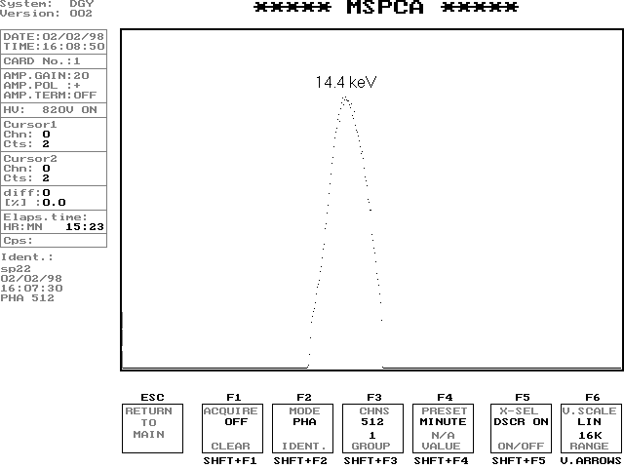

Figure 3. Gated amplitude spectrum of the Co-57 source.

Figure 4. Mössbauer spectrum display in VERT. AUTO SCALE mode.
INSTALLATION INSTRUCTIONS
FOR THE MSPCA CARD

Before you place the MSPCA analyzer card into your PC please make a subdirectory on the hard disk, and copy the files from the shipped distribution diskette (MSPCA.EXE, MSPCA.CFG, and IOSPACE.EXE).
The MSPCA.EXE analyzer control and data acquisition program is a DOS based program. For this reason we suggest to use a DOS operating system, or WINDOWS in DOS mode during the installation. Later you can run the MSPCA.EXE program under WINDOWS as a DOS application window.

The I/O interface of the MSPCA card is very simple. The card uses 16 consecutive I/O addresses, and the base address is selectable by microswitches on the card. The factory default setting is 300hex.
The card does not use hardware interrupts or DMA channels.

Please do the following before placing the card into the PC:
Check your PC for free I/O address spaces running the IOSPACE.EXE utility program. This program examines 18 dedicated, suggested I/O spaces (every space contains 16 consecutive addresses) on your PC and displays whether these spaces are used or not by other hardware in the computer.
The simplest and best case, if the 300hex space is free. The shipped MSPCA.CFG configuration file is factory default and is valid for the 300hex I/O address. Important! : The MSPCA.EXE and MSPCA.CFG files have to take place in the same subdirectory.
If the 300hex space is occupied by other hardware, please select another free space, and set the microswitches on the card according to the following table:

I/O ADDR[hex] | MICROSWITCH POSITIONS
 | Addr 9 | addr 8 | addr 7 | addr 6 | Addr 5 | addr 4
180-18F | OFF | ON | ON | OFF | OFF | OFF
190-19F | OFF | ON | ON | OFF | OFF | ON
1A0-1AF | OFF | ON | ON | OFF | ON | OFF
1B0-1BF | OFF | ON | ON | OFF | ON | ON
1C0-1CF | OFF | ON | ON | ON | OFF | OFF
1D0-1DF | OFF | ON | ON | ON | OFF | ON
1E0-1EF | OFF | ON | ON | ON | ON | OFF
220-22F | ON | OFF | OFF | OFF | ON | OFF
230-23F | ON | OFF | OFF | OFF | ON | ON
250-25F | ON | OFF | OFF | ON | OFF | ON
260-26F | ON | OFF | OFF | ON | ON | OFF
2A0-2AF | ON | OFF | ON | OFF | ON | OFF
2B0-2BF | ON | OFF | ON | OFF | ON | ON
300-30F | ON | ON | OFF | OFF | OFF | OFF
310-31F | ON | ON | OFF | OFF | OFF | ON
330-33F | ON | ON | OFF | OFF | ON | ON
350-35F | ON | ON | OFF | ON | OFF | ON
390-39F | ON | ON | ON | OFF | OFF | ON

In this case please delete the MSPCA.CFG configuration file and generate a new one in the following mode:
Run the MSPCA.EXE program on the PC, the MSPCA main menu appears. Select the I/O ADDRESS [HEX] line in the upper window, and set that free I/O space, which you selected by the microswitches on the card.
Press the F5 function key and the new configuration file (MSPCA.CFG) is saved in the subdirectory.

Note: if the 300hex address is occupied and you select another address, you must remove the original default factory MSPCA.CFG file from the directory before running the MSPCA.EXE. If you don’t remove, an I/O address mismatch can occur, because the default config. file configures the MSPCA.EXE program for 300hex I/O address.

Now you can place the analyzer card into your PC. Please run once more the IOSPACE.EXE program, which will display the analyzer card’s I/O address space.

Switch off your computer, wait a few seconds and switch on again, then run MSPCA.EXE.

Connect the HV OUT to the detector HV IN while the computer is switched OFF (Only if the HV board option is installed). Set the required HV polarity (+/-)for the applied detector with the jumper plug-in on the HV board (Computer must be switched OFF). Switch the computer on, run MSPCA.EXE, set the required HV value for the detector and switch on the HV (Ctrl+Hor.arrow).
Important: Never switch on the HV without detector connection!

Examine the analyzer card in PHA mode. Connect a detector or preamplifier output to the AIN input (Analog Input)(BNC connector) on the MSPCA card’s rear panel. Set the amplifier gain and polarity in the main menu according to the input signal. Set PHA mode, and 512 channel numbers. Press the F1 function key. The second graphic menu page appears. Clear the memory sector content (SHIFT+F1). Start the acquisition (press F1). If everything is OK, a PHA spectrum is collecting in the card. You can see the growing spectrum on the screen continuously refreshed. If you use a Co-57 source, you can see the 6.3keV and 14.4keV peaks on the screen (supposing right amplification).
Try to gate the 14.4keV peak with the built-in discriminators. For this reason select DSCR LL by F5 and set the discriminator lower level with the horizontal arrows (acquisition ON). Then select DSCR UL by F5 and set the discriminator upper level. Stop acquisition, clear spectrum. If you now start acquisition again, only the gated peak appears.
Note: for safety reason you can change the discriminator levels only in PHA mode (in MCS mode inhibited).

Examine the analyzer card in MCS mode. Connect the shipped cable to the 9-pin connector at the rear panel of the MSPCA card. Fasten the 9-pin plug to the socket with the appropriate screws! The two BNC plugs of the cable (signed SYNC and DWELL) connect to your Mössbauer spectrometer’s function generator outputs (we suppose DWELL and SYNCHRON outputs).
The DWELL pulses for channel advances must have minimum 300nsec width.
The SYNC pulses are used to synchronize the card to the waveform of the motion and must have minimum 300nsec width. It is important, that the active edge of the SYNC pulse (pos. or neg.) has to occur during the dwell pulse duration.
In the main menu set the MCS-DWELL POL. and EXT-SYNC POL. according to your DWELL and SYNCHRON output polarity. Please select a 512 channel memory group, if the number of DWELL pulses between two SYNC pulses equals 512 or less, select a 1024 channel memory group if the number of DWELL pulses 1024, etc.
Select MCS mode, switch on your Mössbauer transducer and start acquisition. If you use a good caliber absorbent you can notice the Mössbauer spectrum in a few minutes.
Important! In MCS mode the DWELL and SYNC pulses have to be present continuously.

After finishing the collection, save the spectrum in a file (main menu WRITE TO FILE). Mössbauer evaluating programs e.g. MossWin, MMS, directly can read this text file.

At this point the installation is finished. In the future you can start MSPCA.EXE in DOS mode or in WINDOWS as a DOS application. It is mentioned that MSPCA main menu uses text mode, while the second menu page uses graphic mode with DOS graphic routines. For this reason, if you use MSPCA.EXE under WINDOWS, the main menu can be switched between small and full-screen windows, but the second menu page is displayed only in full-screen window.

Finally, we strongly suggest saving the configuration (main menu, upper window, F5) at the beginning of every new long-time Mössbauer measurement! If you set everything for a Mössbauer measurement (amp. gain, polarities, discriminator levels, mode, memory group, display mode, etc.) and save the configuration, the overwritten MSPCA.CFG file will contain all this information. For example, if your measuring period takes a week, and during this time unfortunately the line power failures or stops, you have to reboot your PC. Your spectrum is stored safely in the nonvolatile memory of the card, and when you restart the MSPCA.EXE program, the MSPCA.CFG config. file will reload all the parameters, which were saved at the beginning of the measurement.

IMPORTANT!
Never use your PC containing the MSPCA card with opened cover, or without cover! Please fasten the PC cover with screws!
Please place your monitor as far from your PC as far as possible! Most of the monitors are strong noise sources.
Never switch on the HV without detector connection!

